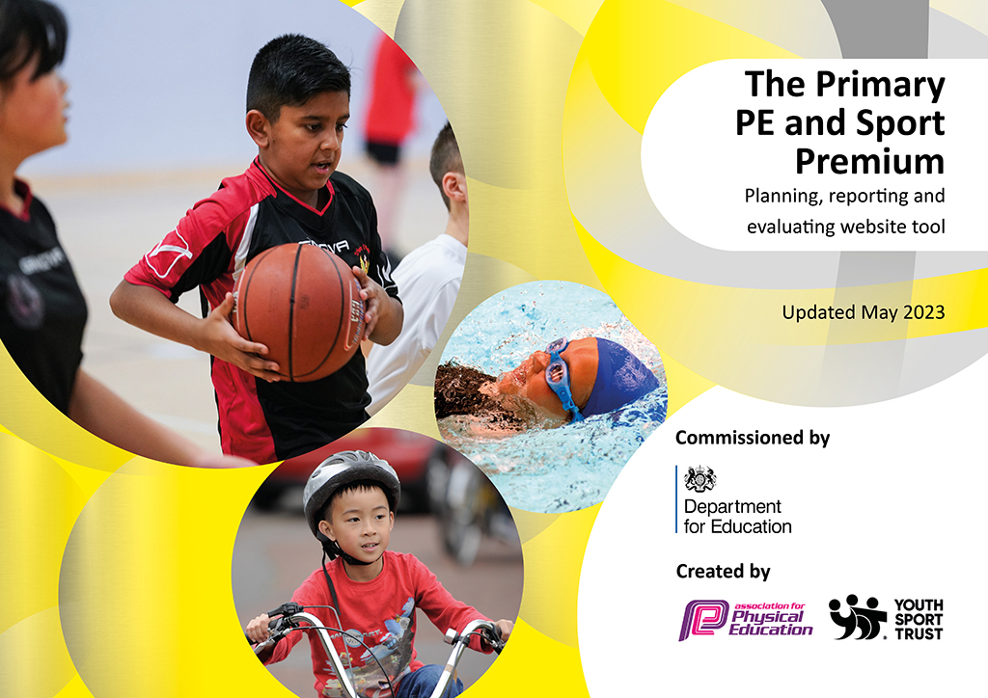
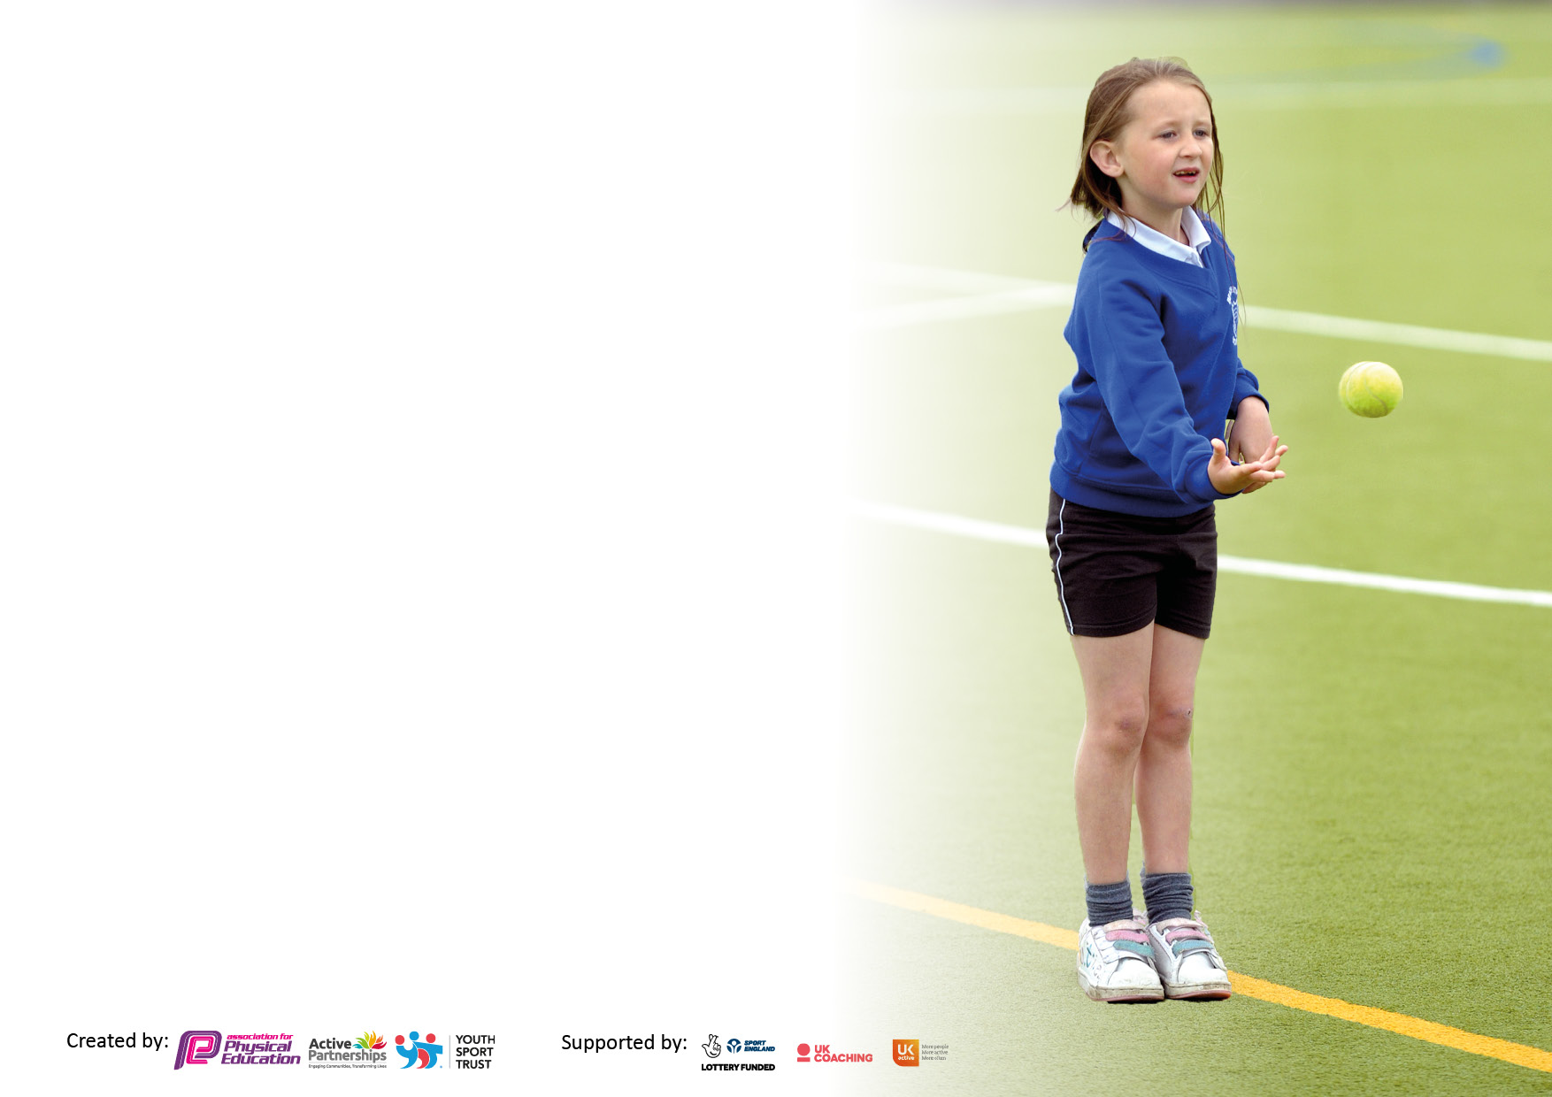

It is important that your grant is used effectively and based on school need. The Education Inspection Framework makes clear there will be a focus on ‘whether leaders and those responsible for governors all understand their respective roles and perform these in a way that enhances the effectiveness of the school’.

Under the Quality of Education Ofsted inspectors consider:
Intent - Curriculum design, coverage and appropriateness
Implementation - Curriculum delivery, Teaching (pedagogy) and Assessment
Impact - Attainment and progress

To assist schools with common transferable language this template has been developed to utilise the same three headings which should make your plans easily transferable between working documents.

Schools must use the funding to make additional and sustainable improvements to the quality of Physical Education, School Sport and Physical Activity (PESSPA) they offer. This means that you should use the Primary PE and sport premium to:

- Develop or add to the PESSPA activities that your school already offer
- Build capacity and capability within the school to ensure that improvements made now will benefit pupils joining the school in future years
- The Primary PE and sport premium should not be used to fund capital spend projects; the school’s budget should fund these.

Please visit gov.uk for the revised DfE guidance including the5keyindicatorsacrosswhichschoolsshoulddemonstrate an improvement. This document will helpyoutoreviewyourprovisionandtoreportyourspend.DfEencouragesschools to use this template as an effective way of meeting the reporting requirements of the Primary PE and Sport Premium.

We recommend you start by reflecting on the impact of current provision and reviewing the previous spend.

Schools are required to publish details of how they spend this funding, including any under-spend from 2021/2022, as well as on the impact it has on pupils’ PE and sport participation and attainment. The funding should be spent by 31st July but the DfE has stated that there will be no clawback of any unspent money so this can be carried forward into 2023/24.

We recommend regularly updating the table and publishing it on your website throughout the year. This evidences your ongoing self-evaluation of how you are using the funding to secure maximum, sustainable impact. Final copy must be posted on your website by the end of the academic year and no later than the 31st July 2023. To see an example of how to complete the table please click HERE.

Details with regard to funding
Please complete the table below.

Total amount carried over from 2021/22 | £ £14,822
Total amount allocated for 2021/22 | £ 17,180
How much (if any) do you intend to carry over from this total fund into 2022/23? | £ 0
Total amount allocated for 2022/23 | £17,180
Total amount of funding for 2022/23. Ideally should be spent and reported on by 31st July 2023. | £ 33,600
Swimming Data
Please report on your Swimming Data below.

Meeting national curriculum requirements for swimming and water safety.  N.B. Complete this section to your best ability. For example you might have practiced safe self-rescue techniques on dry land which you can then transfer to the pool when school swimming restarts.  Due to exceptional circumstances priority should be given to ensuring that pupils can perform safe self rescue even if they do not fully meet the first two requirements of the NC programme of study | NA
What percentage of your current Year 6 cohort swim competently, confidently and proficiently over a distance of at least 25 metres?  N.B. Even though your pupils may swim in another year please report on their attainment on leaving primary school at the end of the summer term 2023.  Please see note above | NA
What percentage of your current Year 6 cohort use a range of strokes effectively [for example, front crawl, backstroke and breaststroke]?  Please see note above | NA
What percentage of your current Year 6 cohort perform safe self-rescue in different water-based situations? | NA
Schools can choose to use the Primary PE and sport premium to provide additional provision for swimming but this must be for activity over and above the national curriculum requirements. Have you used it in this way? | NA

Action Plan and Budget Tracking
Capture your intended annual spend against the 5 key indicators. Clarify the success criteria and evidence of impact that you intend to measure to evaluate for pupils today and for the future.

Academic Year: 2022/23 | Total fund allocated: £17.180 | Date Updated: July 19th 2023
Key indicator 1: The engagement of all pupils in regular physical activity – Chief Medical Officers guidelines recommend that primary school pupils undertake at least 30 minutes of physical activity a day in school |  |  |  | Percentage of total allocation:
 |  |  |  | 60 % £19,200
Intent | Implementation |  | Impact
Your school focus should be clear what you want the pupils to know and be able to do and about  what they need to learn and to  consolidate through practice: | Make sure your actions to achieve are linked to your intentions: | Funding allocated: | Evidence of impact: what do pupils now know and what can they now do? What has changed?: | Sustainability and suggested next steps:
To improve health and fitness of all pupils by engaging all pupils in daily physical activity.  To target more pupils at lunch times to engage with sporting and active opportunities, in order to achieve the 30 minutes needed daily.  . | Playtime games/trolley  Lunchtime games/trolley  Purchase a wide range of equipment for all year groups to participate in active games during lunchtime and break times | £2000 | All children are active for a minimum of 30 minutes every day through playtimes, lunchtime and PE.  Children have access to a wider variety of games than before.  Children are self-selecting activity rather than it being adult led. | PE leader to observe and monitor the children at lunchtimes. Notice any children who are not physically active.  Gather pupil voice about PE equipment.  Carry out a playtime survey
To provide young leaders training so that (PALS) so that younger children have good role models for playing sport.  To raise motivation for pupils to participate in sporting activities at lunch/break times | Purchase leadership training for Y2 class to be lunchtime leaders (PALS).  Year 2 being ‘Young Leaders’ Autumn 23 from SRSP for breaktime games | £300 | Reception children have positive active role models at play/lunchtimes  Those less engaged children are more motivated and are accessing physical activity.
To provide access to additional physical activity | Provide a range of weekly after school clubs.  Encourage those children who are less active to join the clubs |  | School has provided at least 2 after school clubs per week (Spring 2 and Summer 1, 3 clubs per week through SRBC sports projects | School staff to deliver additional PE clubs to offer access to more children
To improve Year 2 children’s resilience and build physical strength | Year 2 children take part in Military School Activities for the summer term | £6000 | Evidence of a growth in confidence in quieter children  Children’s stamina has increased
To teach children effective strategies for developing a healthy mind | Whole school mindfulness days focusing on yoga type physical activities and calming mind activities  Yogi coaches in school for the day | £0 | Children have a range of strategies they can use to calm themselves and build positive mind sets | Build in daily mindfulness activities
Provide access to physical development interventions in EYFS | Purchase BEAM interventions and enable key staff to access training | £200 | Children with weaker gross motor skills have access to intervention | This can be repeated each year with new intake of children and children with ongoing weaker gross motor issues
Improve the outdoor provision so that children can still engage in physical activity throughout the summer months currently there are no shaded areas so children are less active when it is hot | Purchase shade sails to cover the sunniest part of the playground | £11,000 | Children are engaging in physical activity at lunchtimes/playtimes during the hitter weather instead of sitting down | Ongoing access
Key indicator 2: The profile of PESSPA being raised across the school as a tool for whole school improvement |  |  |  | Percentage of total allocation:
 |  |  |  | 5% % £1700
Intent | Implementation |  | Impact
Your school focus should be clear what you want the pupils to know and be able to do and about  what they need to learn and to  consolidate through practice: | Make sure your actions to achieve are linked to your intentions: | Funding allocated: | Evidence of impact: what do pupils now know and what can they now do? What has changed?: | Sustainability and suggested next steps:
To provide professional development for the PE lead  To provide a progressive, sequenced teaching programme for children to follow building on prior learning and skills  To ensure High quality PE lessons delivered during curriculum time. | PE consultant to work 1:1 with PE lead to check the quality of the curriculum offer and make adaptations where required  PE lead attend termly PE subject leader training and disseminate training to staff  PE lead deliver termly staff training | £500  £600  £0 | The PE curriculum is effective, progressive and sequenced  The PE has up to date subject knowledge  Staff have increased subject knowledge  PE teaching is good-subject leader monitoring | PE lead is on maternity leave. Ensure the temporary PE lead has access to CPD
To implement an effective assessment process to ensure that children are meeting physical development milestones | Lancashire PE passport | £600 | Effective assessment system in place  Gaps in physical development is identified  Interventions can be planned accordingly | Sustainability on access the high quality scheme of work and assessment

Key indicator 3: Increased confidence, knowledge and skills of all staff in teaching PE and sport |  |  |  | Percentage of total allocation:
 |  |  |  | 25% £8000
Intent | Implementation |  | Impact
Your school focus should be clear | Make sure your actions to | Funding | Evidence of impact: what do | Sustainability and suggested
what you want the pupils to know | achieve are linked to your | allocated: | pupils now know and what | next steps:
and be able to do and about | intentions: |  | can they now do? What has
what they need to learn and to |  |  | changed?:
consolidate through practice:
Teaching staff an access sequenced lesson plans to support their delivery of quality PE teaching (PE passport) and develop their subject knowledge | Purchase the PE passport app | £7000 | PE lessons delivered will be of high quality | On going CPD
Set up teaching pairs so that teachers can observe each other teaching PE and offer effective feedback | Teachers pair up to provide effective monitor ad feedback to improve/embed quality teaching | £1000 | PE lessons delivered will be of high quality | On going CPD
Key indicator 4: Broader experience of a range of sports and activities offered to all pupils |  |  |  | Percentage of total allocation:
Intent | Implementation |  | Impact | 9 % £2900
Your school focus should be clear | Make sure your actions to | Funding | Evidence of impact: what do | Sustainability and suggested
what you want the pupils to know | achieve are linked to your | allocated: | pupils now know and what | next steps:
and be able to do and about | intentions: |  | can they now do? What has
what they need to learn and to |  |  | changed?:
consolidate through practice:
Scoot safe – Year 2 • Bike ability – level 1 and 2 for reception children  • A range of after school clubs available to children | All year 2 participate in scoot safe sessions  • All reception children participate in bike ability level 1 and 2.  Continual access to balance bikes in outdoor area.  • Have a range of after school clubs. | Bike ability: £900 SRSP Clubs: £1,400  Zumba Clubs: £600 | Children taking part in different physical activities and sports that they haven’t tried before  children gain confidence in new activities | Children are developing a love for physical activity and access new experiences

Key indicator 5: Increased participation in competitive sport |  |  |  | Percentage of total allocation:
 |  |  |  | 6 %
Intent | Implementation |  | Impact | £1800
Your school focus should be clear | Make sure your actions to | Funding | Evidence of impact: what do | Sustainability and suggested
what you want the pupils to know | achieve are linked to your | allocated: | pupils now know and what | next steps:
and be able to do and about | intentions: |  | can they now do? What has
what they need to learn and to |  |  | changed?:
consolidate through practice:
• Focus on competition within school using Whole School Festivals with SRSP - Paralympics, Rackets, Athletics •Providing opportunities for children with SEND, the least active and the least confident to participate in competitions. • Sports Day | Whole school Festivals - Termly  Sports/Healthy Week  Sports Day  Engage with SRSP competitions | Whole School Festivals: £600 Sports Day: £30.00  Cluster competitions: £450 | Our whole school Festivals have been a success this year. We have done a Paralympic Festival, a Rackets Festival and an Athletics Festival. We link our Christian values with our festivals, handing out ‘perseverance’ and ‘respect’ certificates to children in each class. | Continue next year with the hope for more competition participation with another local infant school via SRSP. More Whole school festivals with SRSP (half termly)

Signed off by
Head Teacher: | Jayne Woan
Date: | 19th July 2023
Subject Leader: | Jodie East
Date: | 19th July 2023
Governor: | Elizabeth Glassbrook
Date: | 19th July 2023

