St Andrew’s C of Infant School - Pupil premium strategy statement 2023 - 2024
This statement details our school’s use of pupil premium (and recovery premium) funding to help improve the attainment of our disadvantaged pupils.
It outlines our pupil premium strategy, how we intend to spend the funding in this academic year and the outcomes for disadvantaged pupils last academic year.

School overview
Detail | Data
Number of pupils in school | 139
Proportion (%) of pupil premium eligible pupils | (34) 25%  National ave 24%
Academic year/years that our current pupil premium strategy plan covers (3 year plans are recommended – you must still publish an updated statement each academic year) | 2023 - 2024
Date this statement was published | 7th December 2023
Date on which it will be reviewed | 3rd September 2024
Statement authorised by | Jayne Woan
Pupil premium lead | Andrea Ashcroft
Governor / Trustee lead | TBC

Funding overview
Detail | Amount
Pupil premium funding allocation this academic year | £47,145
Recovery premium funding allocation this academic year  Recovery premium received in academic year 2023/24 cannot be carried forward beyond August 31, 2024. | £6,695
Pupil premium funding carried forward from previous years (enter £0 if not applicable) | £0
Total budget for this academic year  If your school is an academy in a trust that pools this funding, state the amount available to your school this academic year | £53,840

Part A: Pupil premium strategy plan

Statement of intent
Our School Vision Statement
‘Learning, Caring and Growing together in Faith’
St. Andrew’s C of E Infant School is a Christian school where children are happy, nurtured and love learning. Through an inspiring and aspirational curriculum, we strive to ensure our children flourish spiritually, academically, and creatively to become confident, resilient learners. Everyone here learns, cares and grows together in faith.​

The School’s vision statement highlights that we are a school team and that everyone works towards the same goal: enabling every child to reach their full potential as part of a Christian family and in the wider community.
When making decisions about using Pupil Premium funding, we consider the context of our school and any particular challenges our families face alongside the research conducted by the EEF. Consideration has been given to the three key areas of high-quality teaching, targeted academic support and wider strategies.
We have found that common barriers to learning for disadvantaged children at our school can be: underdeveloped language and communication skills, lack of confidence, less support at home, more frequent behaviour difficulties and attendance and punctuality issues. Complex family situations that prevent children from flourishing may also be contributory factors. We will ensure that all teaching staff are involved in the analysis of data and identification of pupils, so that they are fully aware of strengths and weaknesses across the school.
- We ensure that teaching and learning opportunities meet the needs of all the pupils.

- We ensure that appropriate provision is made for pupils who belong to vulnerable groups, this includes ensuring that the needs of socially disadvantaged pupils are adequately assessed and addressed.

- In making provision for socially disadvantaged pupils, we recognise that not all pupils who receive free school meals will be socially disadvantaged.

- We also recognise that not all pupils who are socially disadvantaged are registered or qualify for free school meals.
We reserve the right to allocate the Pupil Premium funding to support any pupil or groups of pupils the school has legitimately identified as being socially disadvantaged.
• Pupil premium funding will be allocated following a needs analysis which will identify priority classes, groups or individuals. Limited funding and resources mean that not all children receiving free school meals will be in receipt of pupil premium interventions at one time
Leyland St. Andrew’s is a voluntary controlled Infant School in the Leyland. The current intake for each year group is 60. The vast majority of pupils are of White British heritage. The proportion of pupils who are identified as disadvantaged and supported by the pupil premium is below the national average.
The proportion of pupils who have special educational needs is below the national average. The proportion of those who have disability or have a statement of special educational needs or an education, health and care plan is also below the national average.
Ultimate Objectives:
To narrow the attainment gap between disadvantaged and non-disadvantaged pupils nationally and also within internal school data. ·
For all disadvantaged pupils in school to at least reach nationally expected progress rates in order to reach Age Related Expectation at the end of Year 2 in Reading, writing and maths
To ensure that all disadvantaged pupils have access to the enriched curriculum across school.

Challenges
This details the key challenges to achievement that we have identified among our disadvantaged pupils.
Challenge number | Detail of challenge
1 | Underdeveloped language and communication skills
2 | Attendance and punctuality issues
3 | Social and emotional challenges and issues
4 | Writing attainment

Intended outcomes
This explains the outcomes we are aiming for by the end of our current strategy plan, and how we will measure whether they have been achieved.
Intended outcome | Success criteria
Quality First Teaching has a focus on communication and language development. | All children can communicate effectively use a broad range of vocabulary and hear and use standard English.
Children with language and communication difficulties have access to high quality intervention and make good progress in the area | Children with language and communication difficulties can effectively communicate with their needs and wants.  Identified staff will have accessed to specific intervention training-Talk Boost and input from Speech and Language Therapists.
Improved attendance and punctuality | Attendance of PP children is above 96%  Attendance for PPG children is monitored and interventions are in place
PPG children make good progress in all areas from their starting points | PPG children’s data will be monitored and interventions pit in place where required
Improved attainment in writing | PP children can write at age related expectations

Activity in this academic year
This details how we intend to spend our pupil premium (and recovery premium) funding this academic year to address the challenges listed above.

Teaching (for example, CPD, recruitment and retention)
Budgeted cost: £ 2,000
Activity | Evidence that supports this approach | Challenge number(s) addressed
Whole School language and communication training | EEF research and recommendations  https://educationendowmentfoundation.org.uk/education-evidence/early-years-toolkit/communication-and-language-approaches | 1, 3, 4
Quality First Teaching Strategies training(e.g. effective questioning), | EEF Teaching and Learning Toolkit  https://educationendowmentfoundation.org.uk/education-evidence/teaching-learning-toolkit  DFE Menu of Approaches  https://assets.publishing.service.gov.uk/government/uploads/system/uploads/attachment_data/file/1147853/Using_pupil_premium_guidance_for_school_leaders.pdf#page=8 | 1, 3, 4
Staff training on writing development | EEF Teaching and Learning Toolkit  https://educationendowmentfoundation.org.uk/education-evidence/teaching-learning-toolkit  Effective Professional Guidance Report  https://educationendowmentfoundation.org.uk/education-evidence/guidance-reports/effective-professional-development | 4
Emotional Literacy Support Assistant (ELSA) training | EEF Teaching and Learning Toolkit  Effective Professional Guidance Report  https://educationendowmentfoundation.org.uk/education-evidence/teaching-learning-toolkit/social-and-emotional-learning | 1, 2, 3, 4

Targeted academic support (for example, tutoring, one-to-one support, structured interventions)
Budgeted cost: £ 24,340
Activity | Evidence that supports this approach | Challenge number(s) addressed
Talk boost training and resources for identified staff | EEF research and recommendations  https://educationendowmentfoundation.org.uk/education-evidence/teaching-learning-toolkit/oral-language-interventions | 1, 2, 3, 4
Daily reading and writing intervention for underachieving children | Supports disadvantaged children to close the attainment gaps  https://educationendowmentfoundation.org.uk/support-for-schools/bitesize-support/closing-the-attainment-gap | 1, 3, 4
Specialist teacher support advice and intervention | Early intervention is the most effective way to support children  Specialist teacher advice targets specific issues and support class teachers to improve practice  https://educationendowmentfoundation.org.uk/support-for-schools/bitesize-support/closing-the-attainment-gap | 1, 2, 3
Small group and 1:1 tutoring for identified children | Short term targeted intervention linked to ongoing assessment closes attainment gaps https://educationendowmentfoundation.org.uk/education-evidence/teaching-learning-toolkit/individualised-instruction  https://educationendowmentfoundation.org.uk/education-evidence/teaching-learning-toolkit/small-group-tuition | 1, 3, 4
Year 2 boosters  6 hours per week | Short term targeted writing intervention linked to ongoing assessment closes attainment gaps https://educationendowmentfoundation.org.uk/education-evidence/teaching-learning-toolkit/small-group-tuition | 4
SALT interventions | 1:1 interventions to support children to develop the language acquisition and communication skills  https://educationendowmentfoundation.org.uk/education-evidence/early-years-toolkit/communication-and-language-approaches | 1, 3, 4

Wider strategies (for example, related to attendance, behaviour, wellbeing)
Budgeted cost: £ 27,500
Activity | Evidence that supports this approach | Challenge number(s) addressed
Lego Therapy | EEF research and recommendations  https://educationendowmentfoundation.org.uk/education-evidence/teaching-learning-toolkit/social-and-emotional-learning | 1, 2, 3, 4
Emotional Literacy Support Assistant (ELSA) | EEF research and recommendations  https://educationendowmentfoundation.org.uk/education-evidence/teaching-learning-toolkit/social-and-emotional-learning | 1, 2, 3, 4
Redeployment of a TA to improve punctuality and attendance: Attendance leader in post | Effective working with families to improve attendance, improved attendance links to higher attainment  https://www.gov.uk/government/publications/school-attendance/framework-for-securing-full-attendance-actions-for-schools-and-local-authorities | 2, 3
Part time Family support worker in post | Support for vulnerable families increases pupil attendance and helps vulnerable children make progress attainment  https://educationendowmentfoundation.org.uk/education-evidence/teaching-learning-toolkit/parental-engagement | 1, 2, 3
Curriculum enrichment experiences and resources | Educational visits and experiences provide excellent experiences and challenges for our pupils that support our children socially and emotionally. | 1, 2, 3, 4
Access to play therapy | Supports children’s emotional health and wellbeing  https://educationendowmentfoundation.org.uk/education-evidence/teaching-learning-toolkit/social-and-emotional-learning | 2, 3

Total budgeted cost: £ 53,840

Part B: Review of the previous academic year

Outcomes for disadvantaged pupils
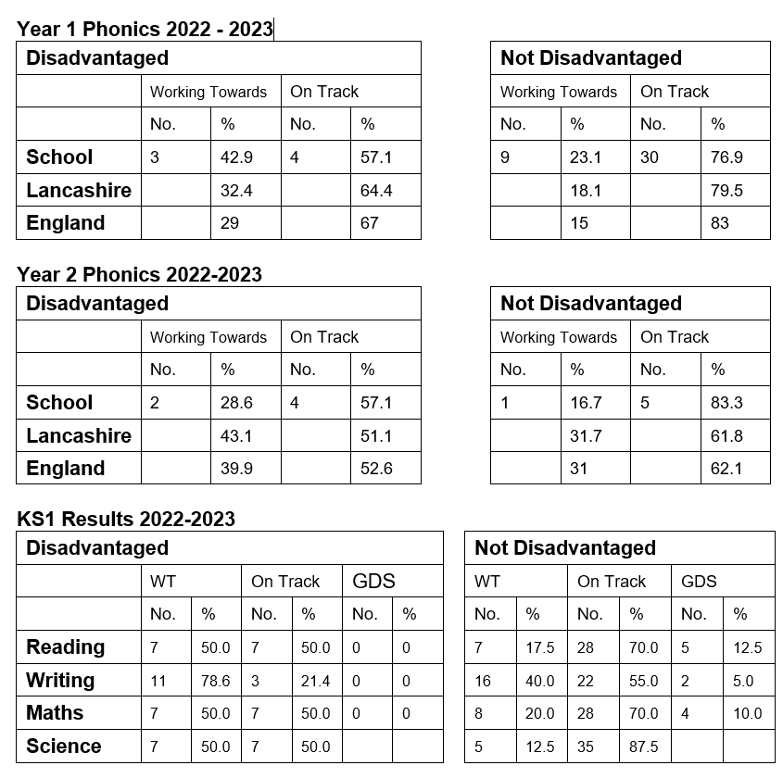
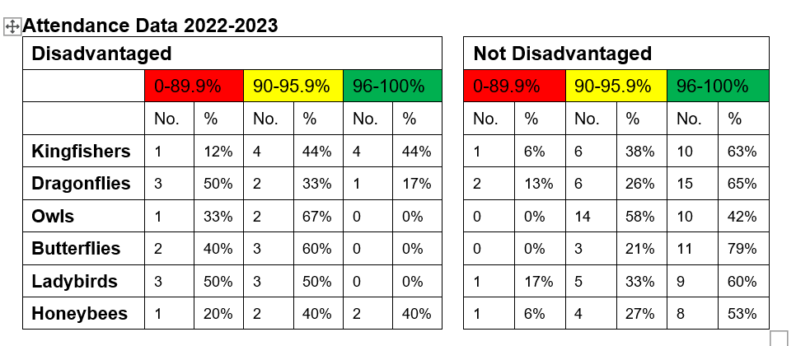worth noting that 4 PPG children have EHCPs and significant medical needs requiring hospital medical appointments.

Intended Outcome | Evaluation
Children with language and communication difficulties have access to high quality intervention and make good progress in the area | - Talk Boost KS1 delivered in EYFS 4 children. End data 3 chn working at age related, 1 child working slightly below.  - 1:1 SALT intervention were delivered to children who required SALT therapy. These were provided to school by speech therapist who supported staff to deliver the interventions in school All with SALT plans children made progress. Number accessing SALT 21 children. 13 children discharged 2022-23.  - 2x EAL children received EMA & NASSEA interventions- significant progress made. Both children On Track at end of EYFS
Improved attendance | - Attendance of PP children is above 90% (Y2 93%, Y1 92% and YR 90%)  - Increased attendance for all PPG children but not achieved 96% attendance (65% of PPG children’s attendance had increased in Summer Term)  - Half termly letters for parents  - Daily wake up calls, first day response home visits in place, relationships developed with parents  - Attendance officer involvement with persistent absentees (PA)  - Fines in place for PA  - Attendance policy in place
Identified staff will have skills, knowledge and resources to be able to support children with emotional needs | - Senior Mental Health training completed Sept 2023  - 1:1 Lego therapy for 2 staff members trained to run interventions in school starting Jan 2024
Progress in reading | - Increased progress but not all PPG children reached ARE (see above for data)  - Parents and children enjoying the new reading scheme-increases in reading for pleasure  - Brilliant Book Awards (BBA) for Year 2 children – reading for pleasure  - Access to Library books and Library Loan boxes  - New home reading books linked to phonic phases

Externally provided programmes
Please include the names of any non-DfE programmes that you used your pupil premium (or recovery premium) to fund in the previous academic year.
Programme | Provider
Effective Questioning | Mandy Peddar LCC
Retrieval Practice | Mandy Peddar LCC
Active Teaching | Many Peddar LCC
Supporting Children with SLC Needs | Sophie Crilly Bridge Speech Therapy
Lego-Based Play Therapy | Reachout ASC
Emotional Literacy Support Assistant Training | LCC

Service pupil premium funding (optional)
For schools that receive this funding, you may wish to provide the following information: How our service pupil premium allocation was spent last academic year
N/A
The impact of that spending on service pupil premium eligible pupils
N/A

Further information (optional)
Use this space to provide any further information about your pupil premium strategy. For example, about your strategy planning, implementation and evaluation, or other activity that you are delivering to support disadvantaged pupils, that is not dependent on pupil premium or recovery premium funding.

