Living Out Our Christian Vision

Butterflies Class

Here’s how we flourish

Summer 1
In Science we have learned all about plants, naming the parts of the plants and learning what they do and learning the names of common flowers.
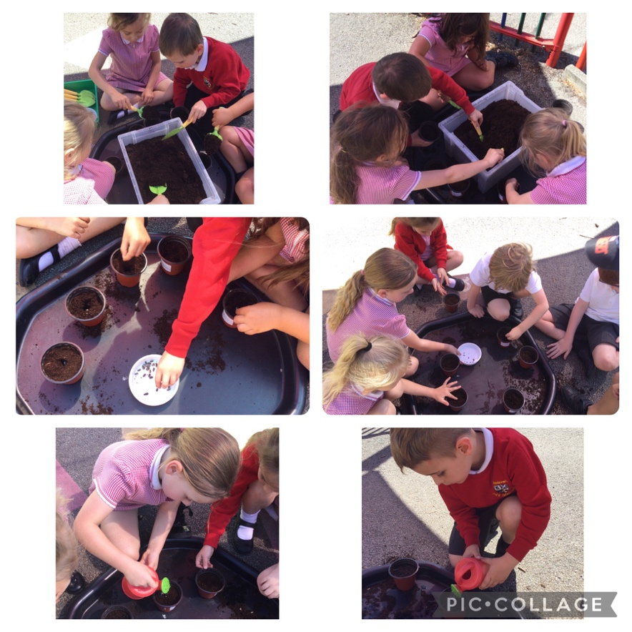

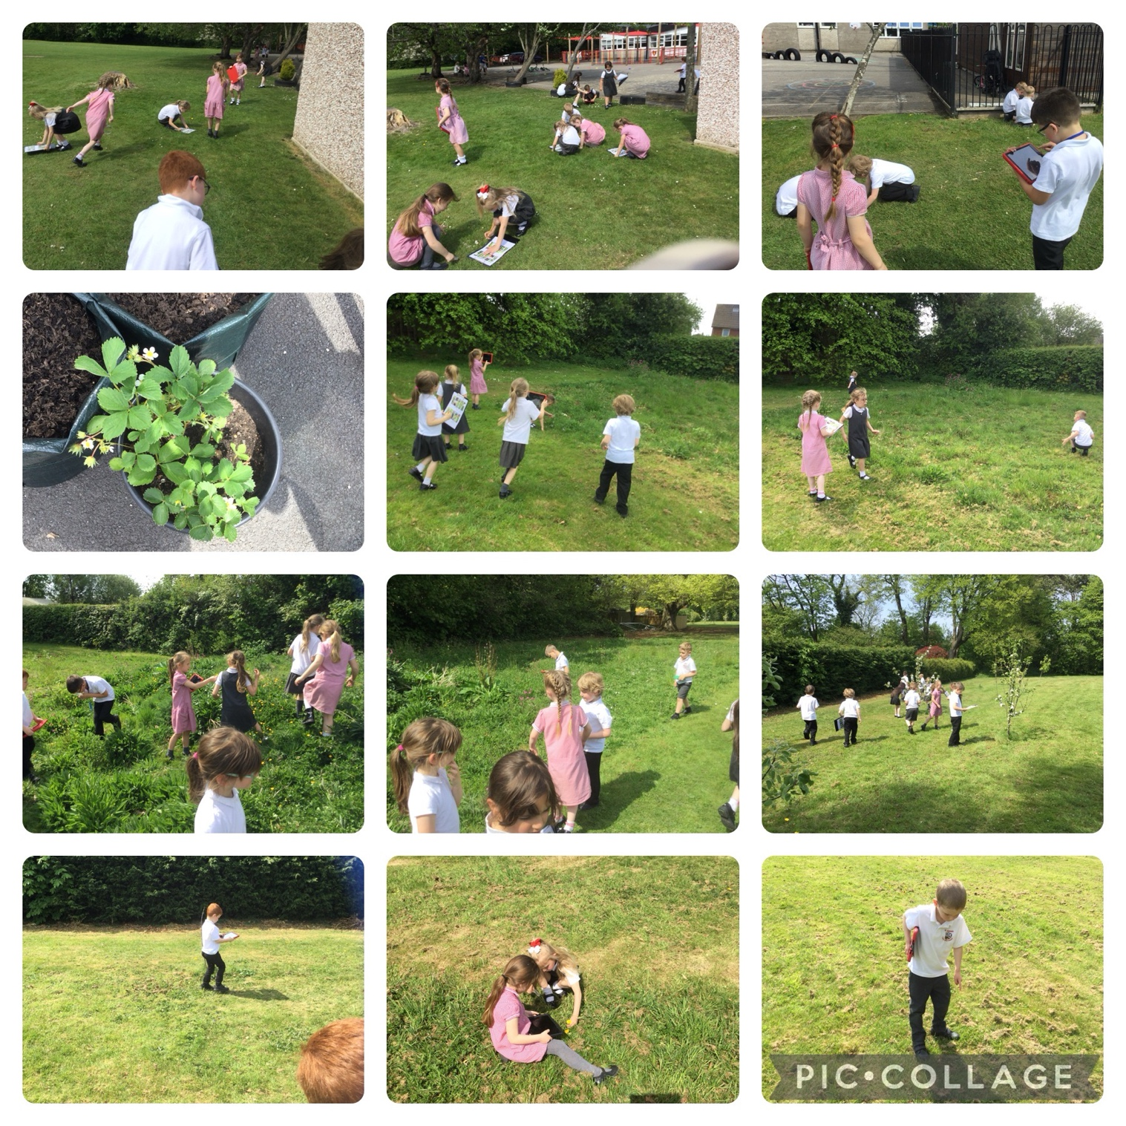
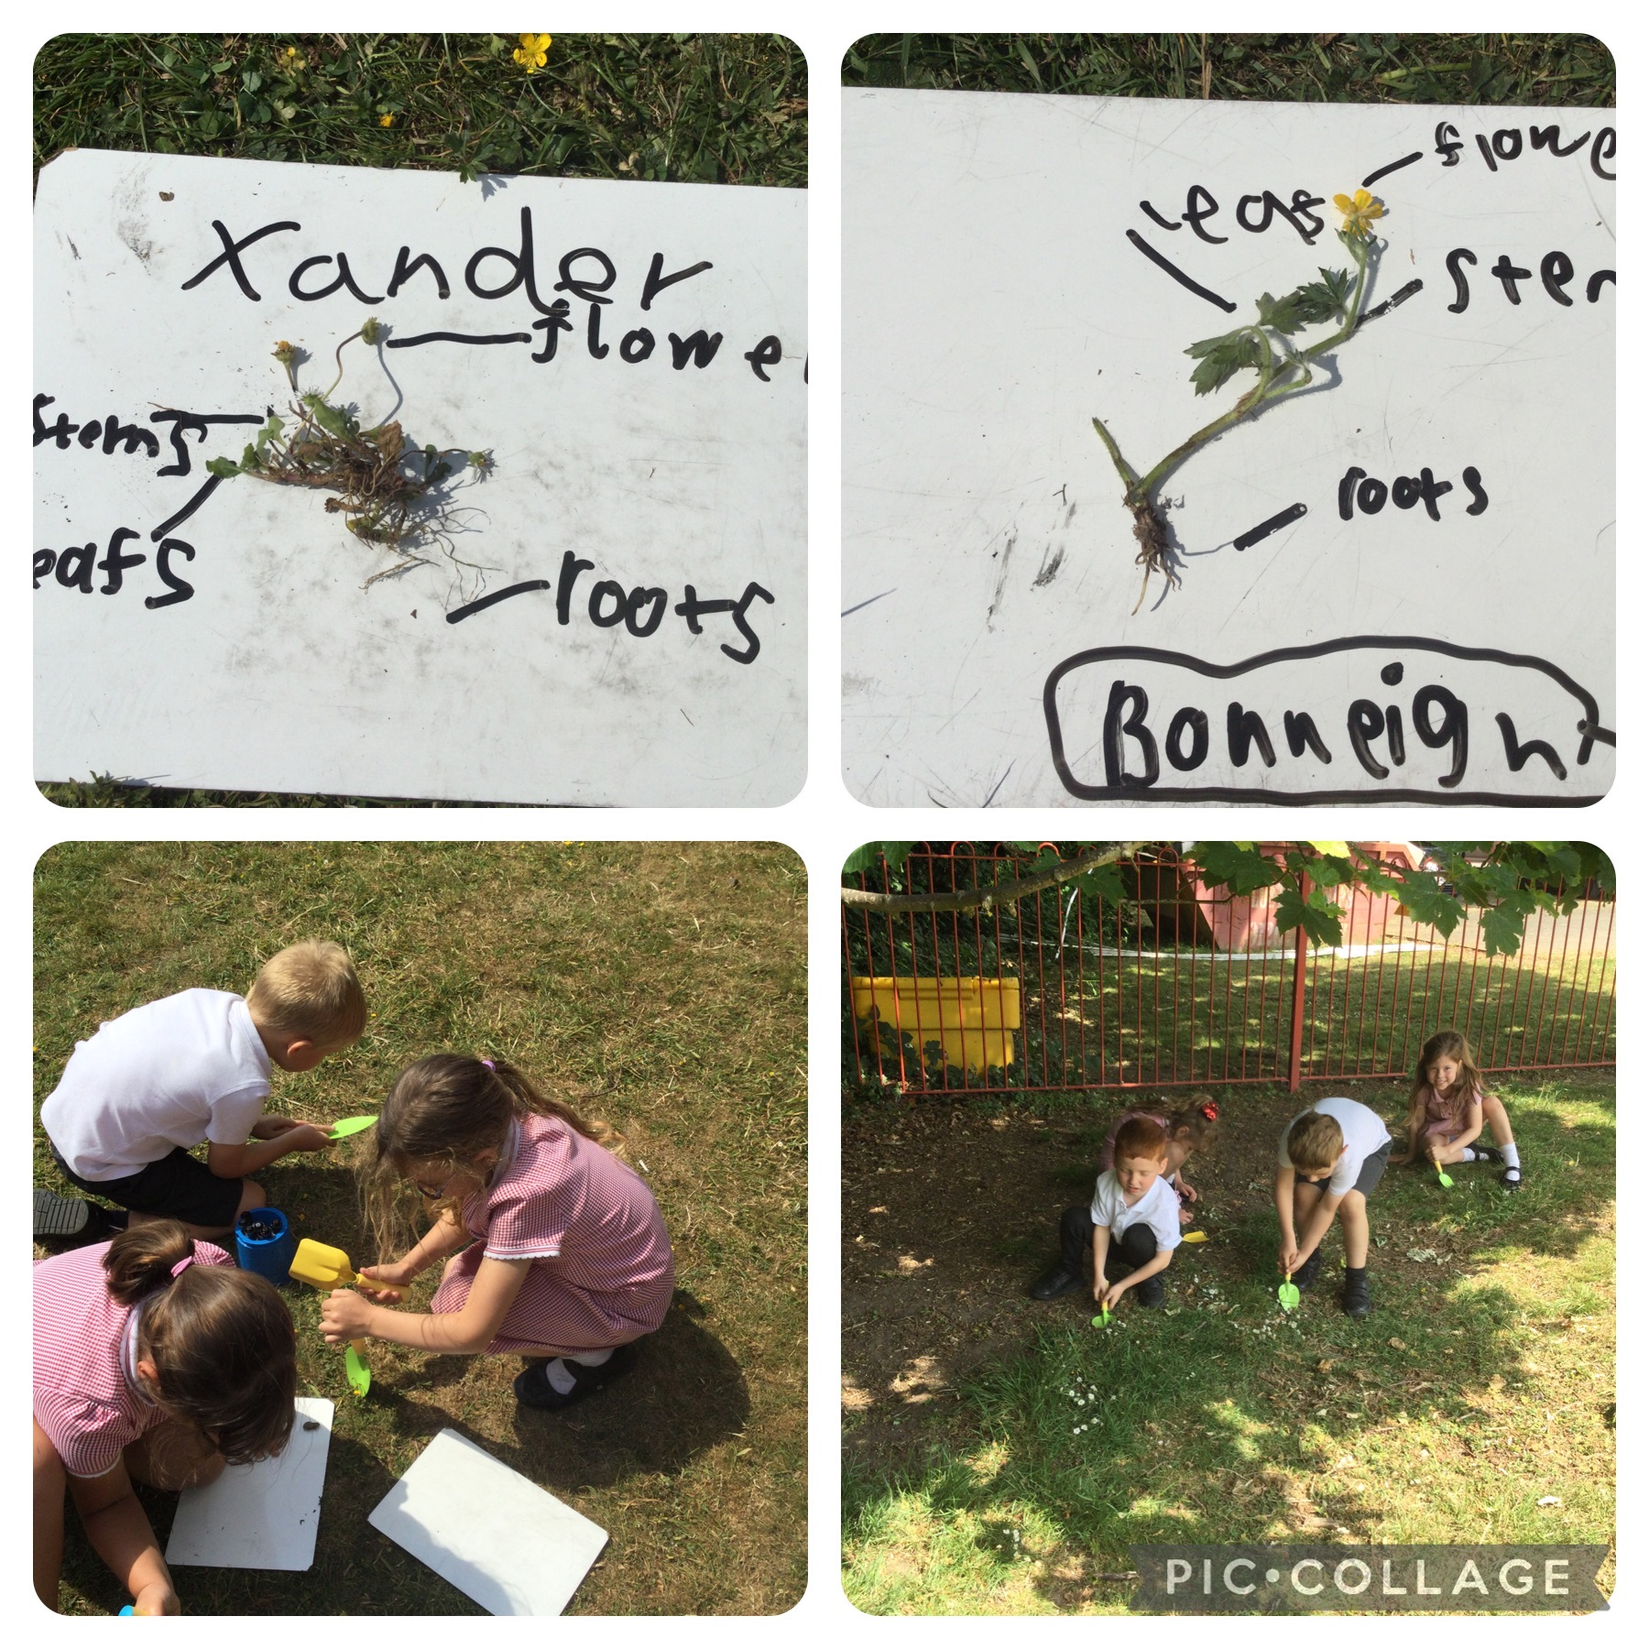
“I loved learning about plants” Xander
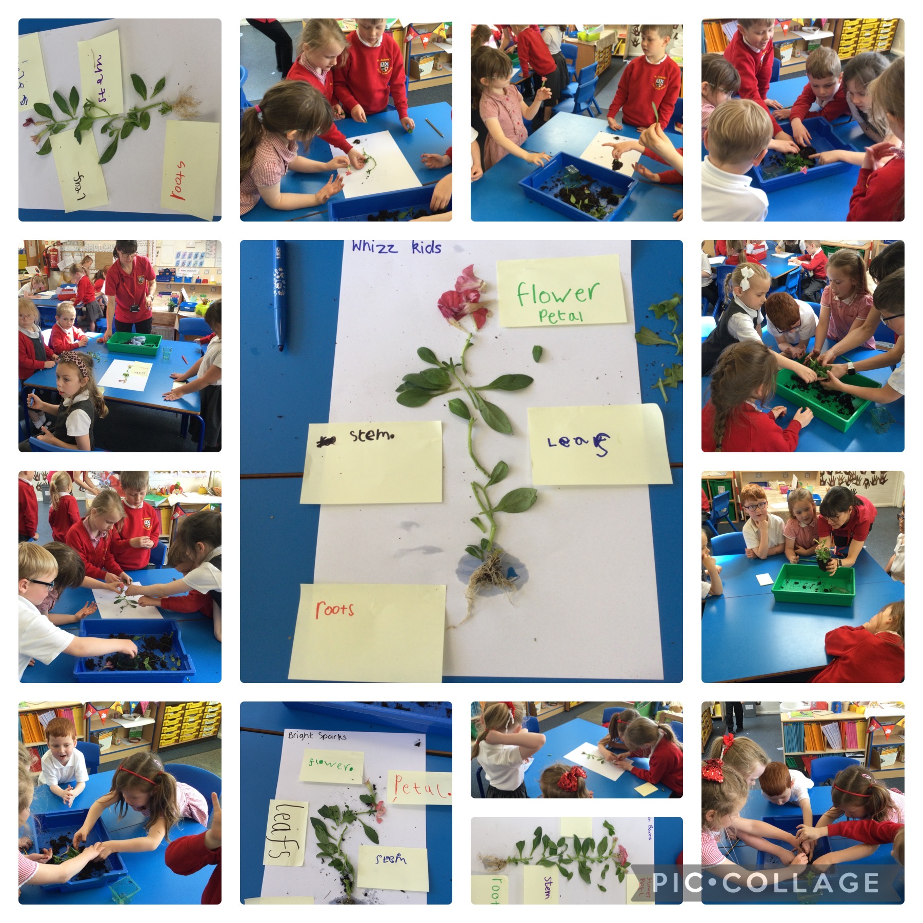
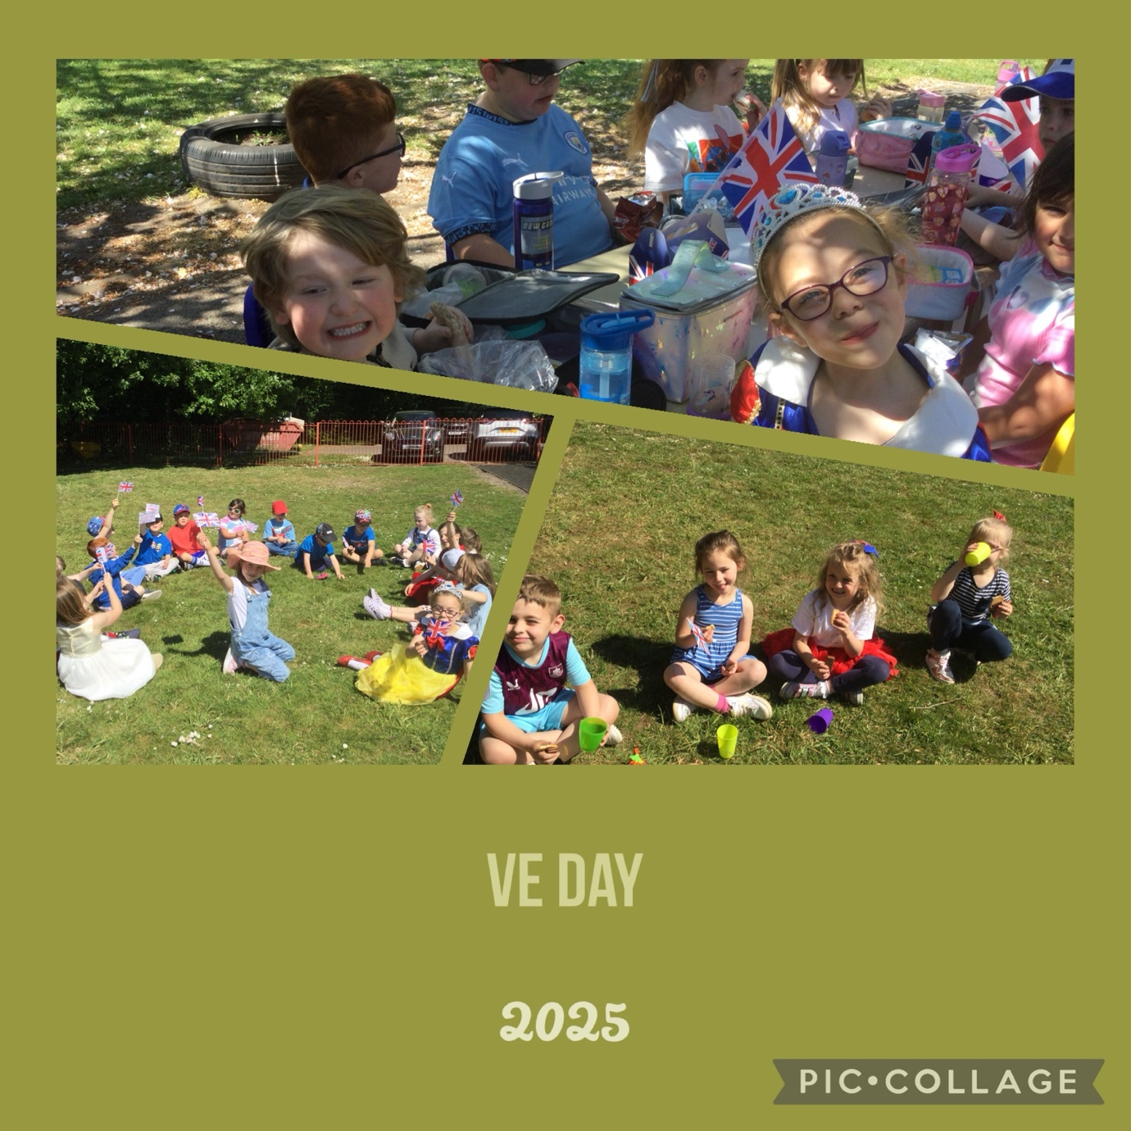

In Art we learned about the Artist Moira West. We practiced plaiting, fraying and twisting materials before making a collage of a Scottish landscape.
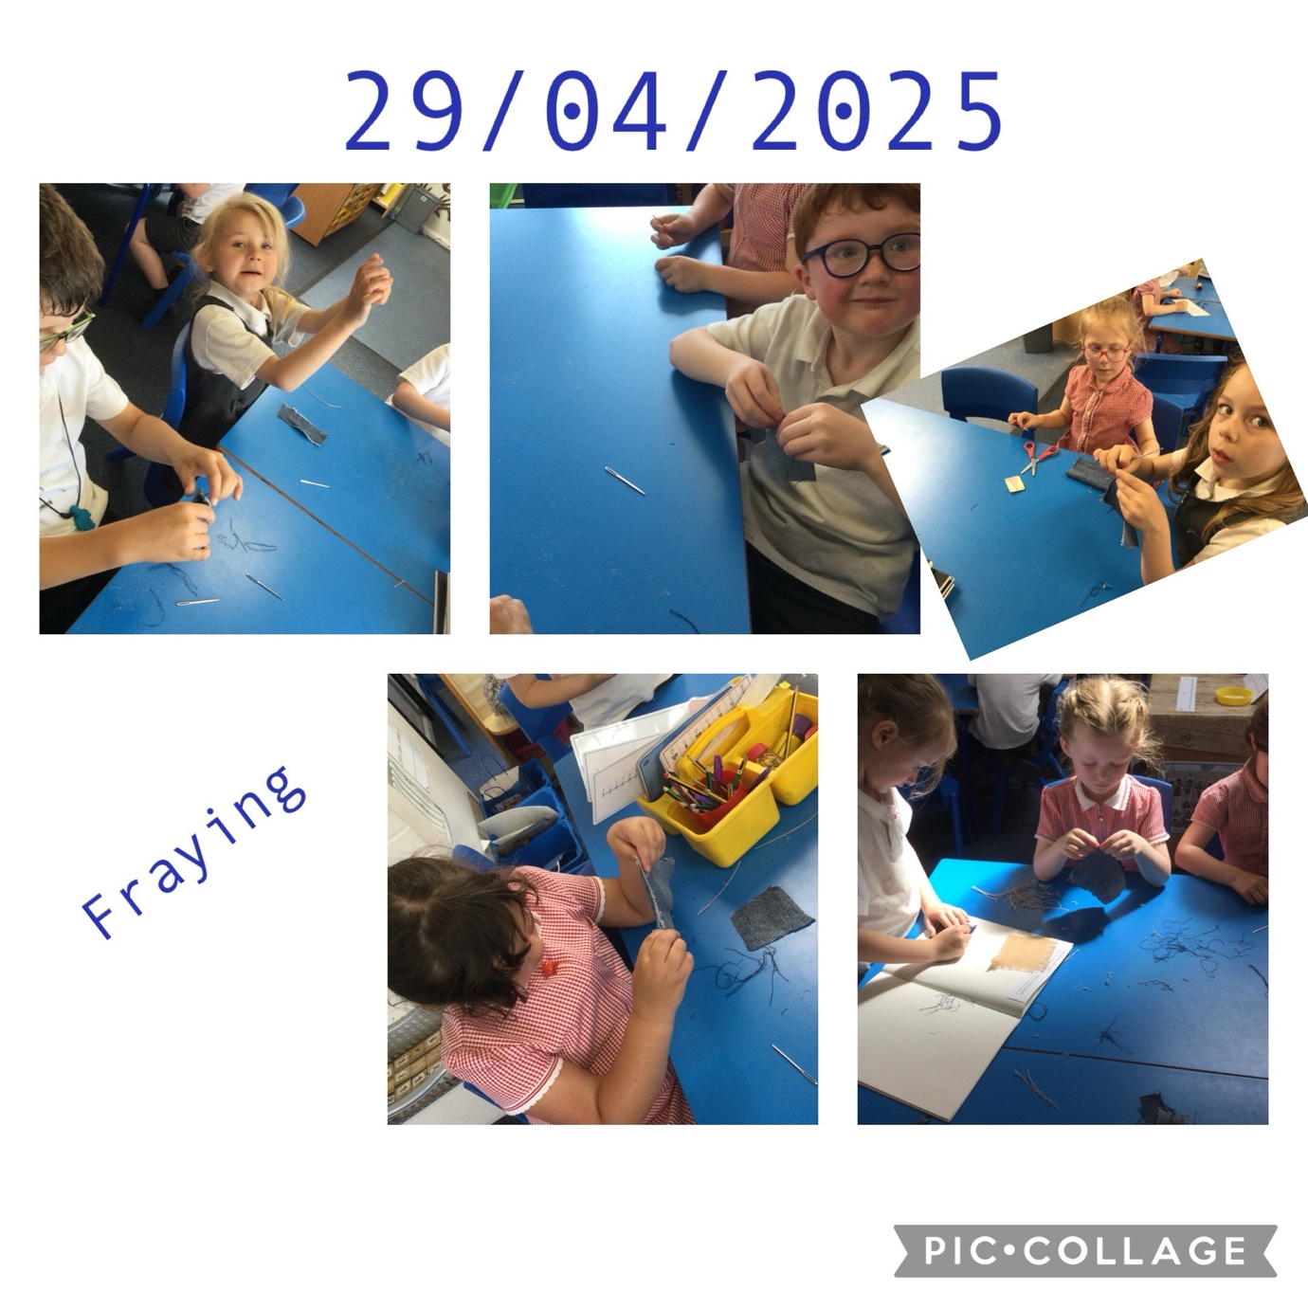
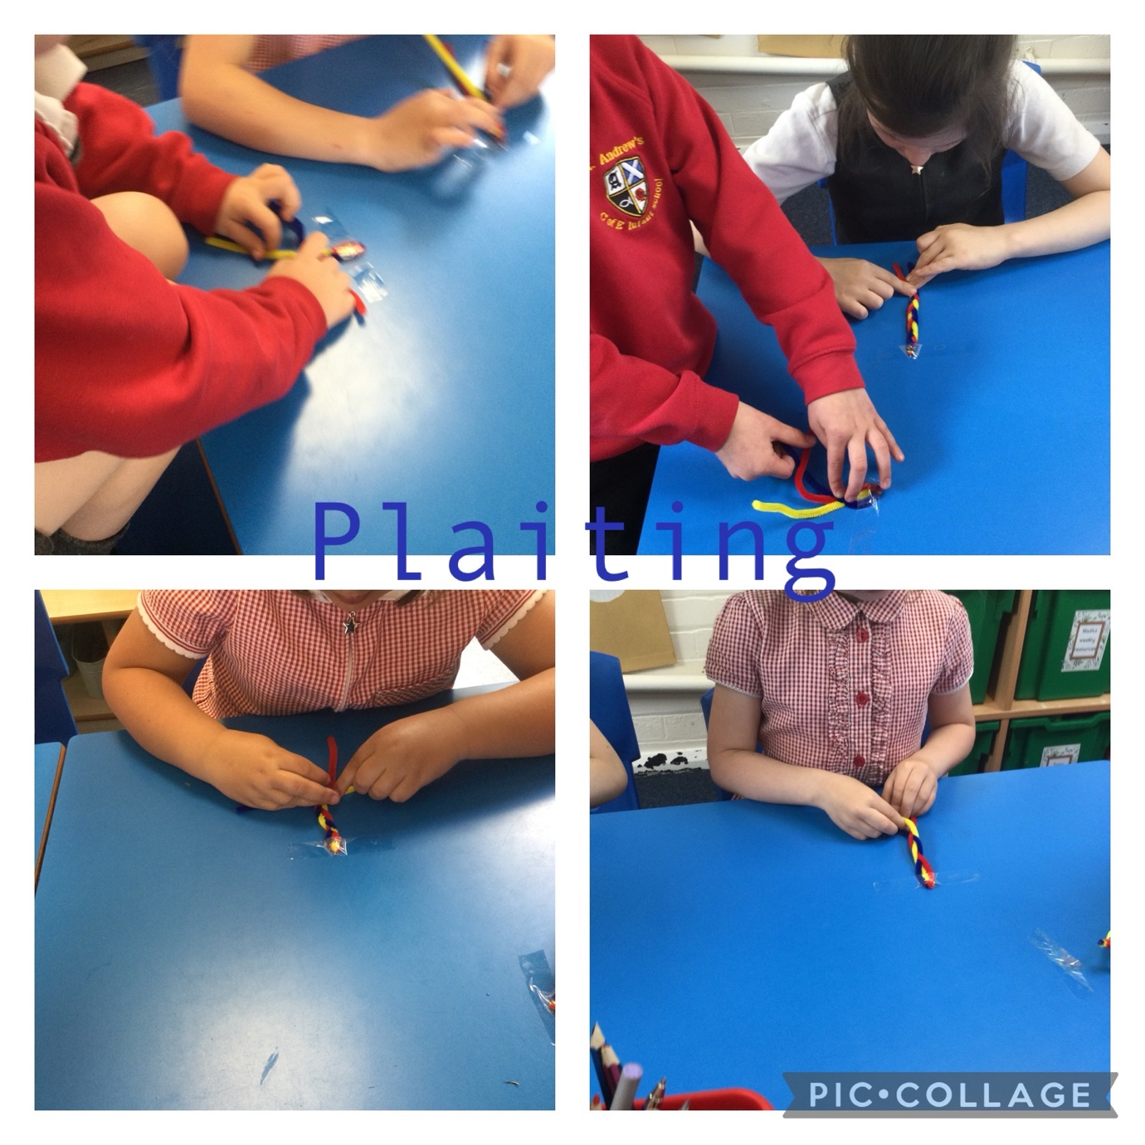
‘We had to persevere to learn how to plait!’ Felix

In Geography we learned about the United Kingdom. We can name the countries, the capitals and the seas. We can also use a compass and an atlas.

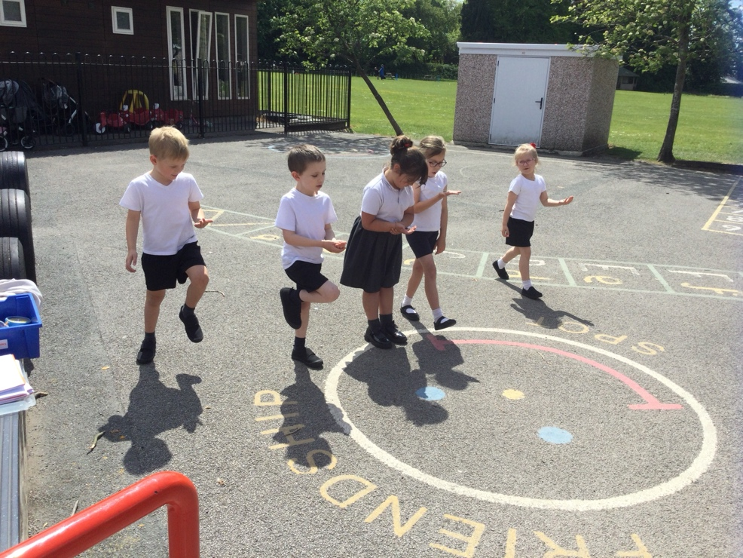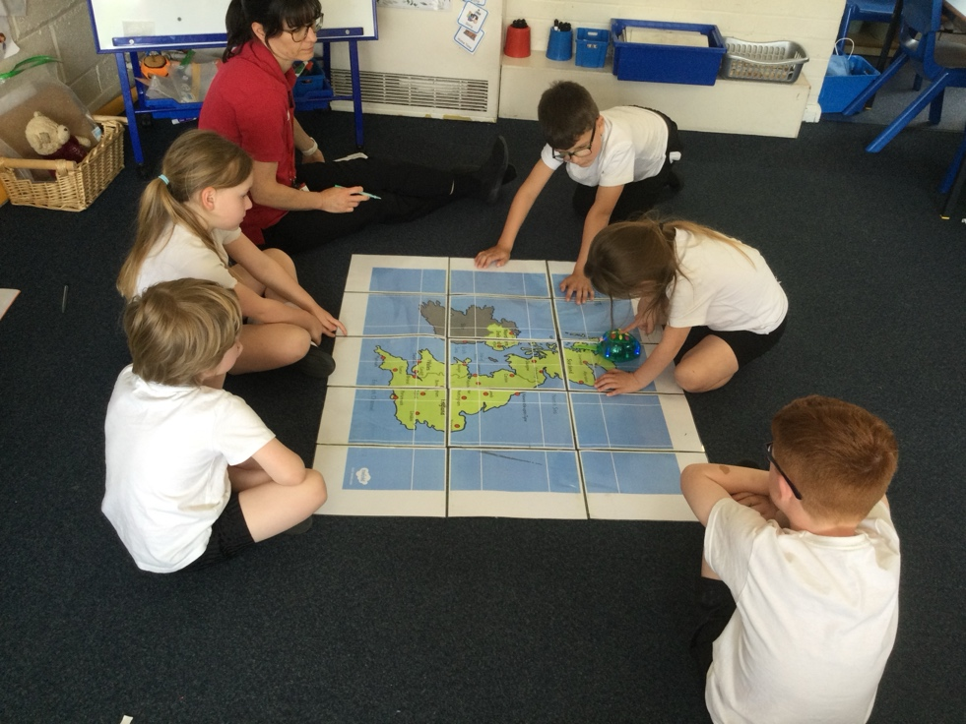

In PE we have been learning how to roll a ball and underarm and over arm throws.
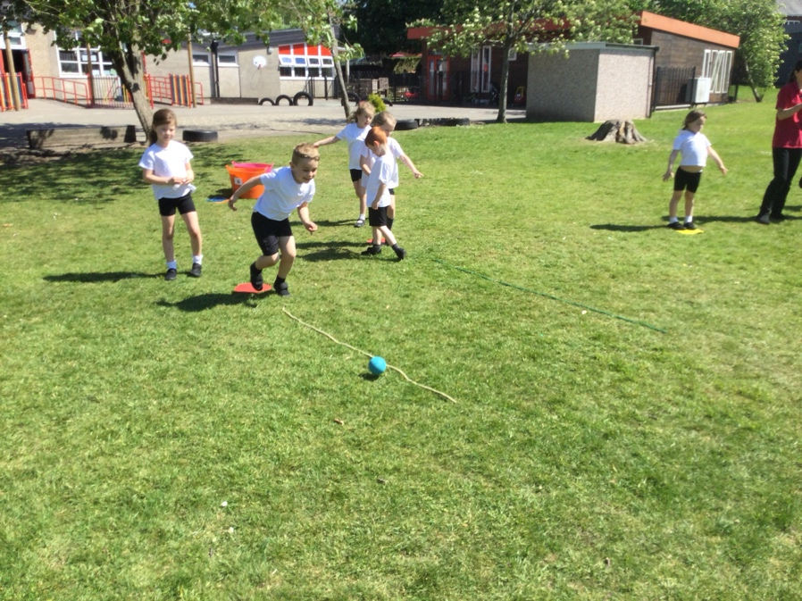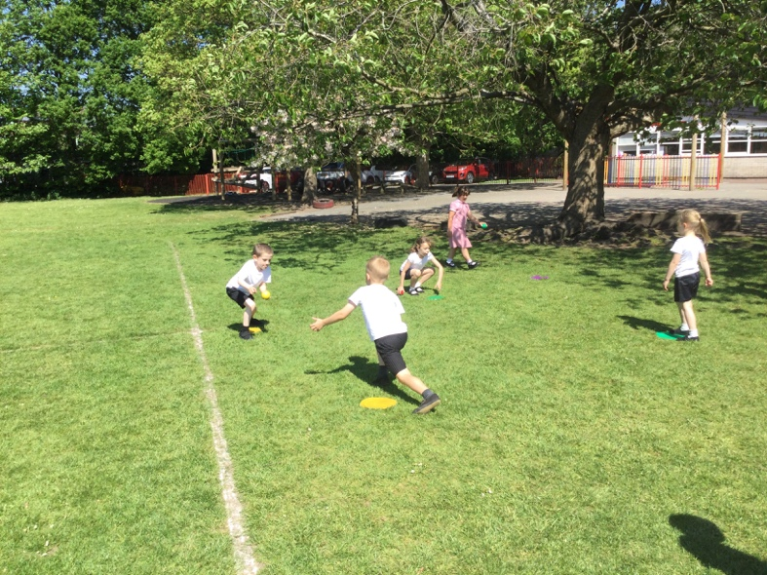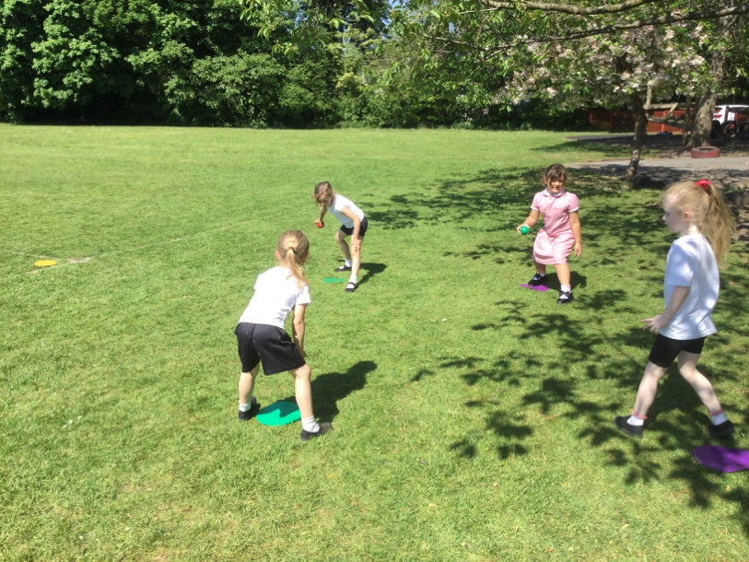

We also enjoyed our cricket session! 