**RE Blog**

**Owls Class**

**Summer 1 – Baptism**

We have been learning about Baptism. We learned about what it means to ‘belong’ we know Jesus was baptised in the River Jordan. We thoroughly enjoyed our trip to St Andrew’s Church to have our own Baptism of baby doll Jen. We role played the ceremony with parents and Godparents. We also looked at the key features of the church e.g. the font. We also learned that people from other faiths welcome new babies in special ways – we looked at how Muslims welcome babies.

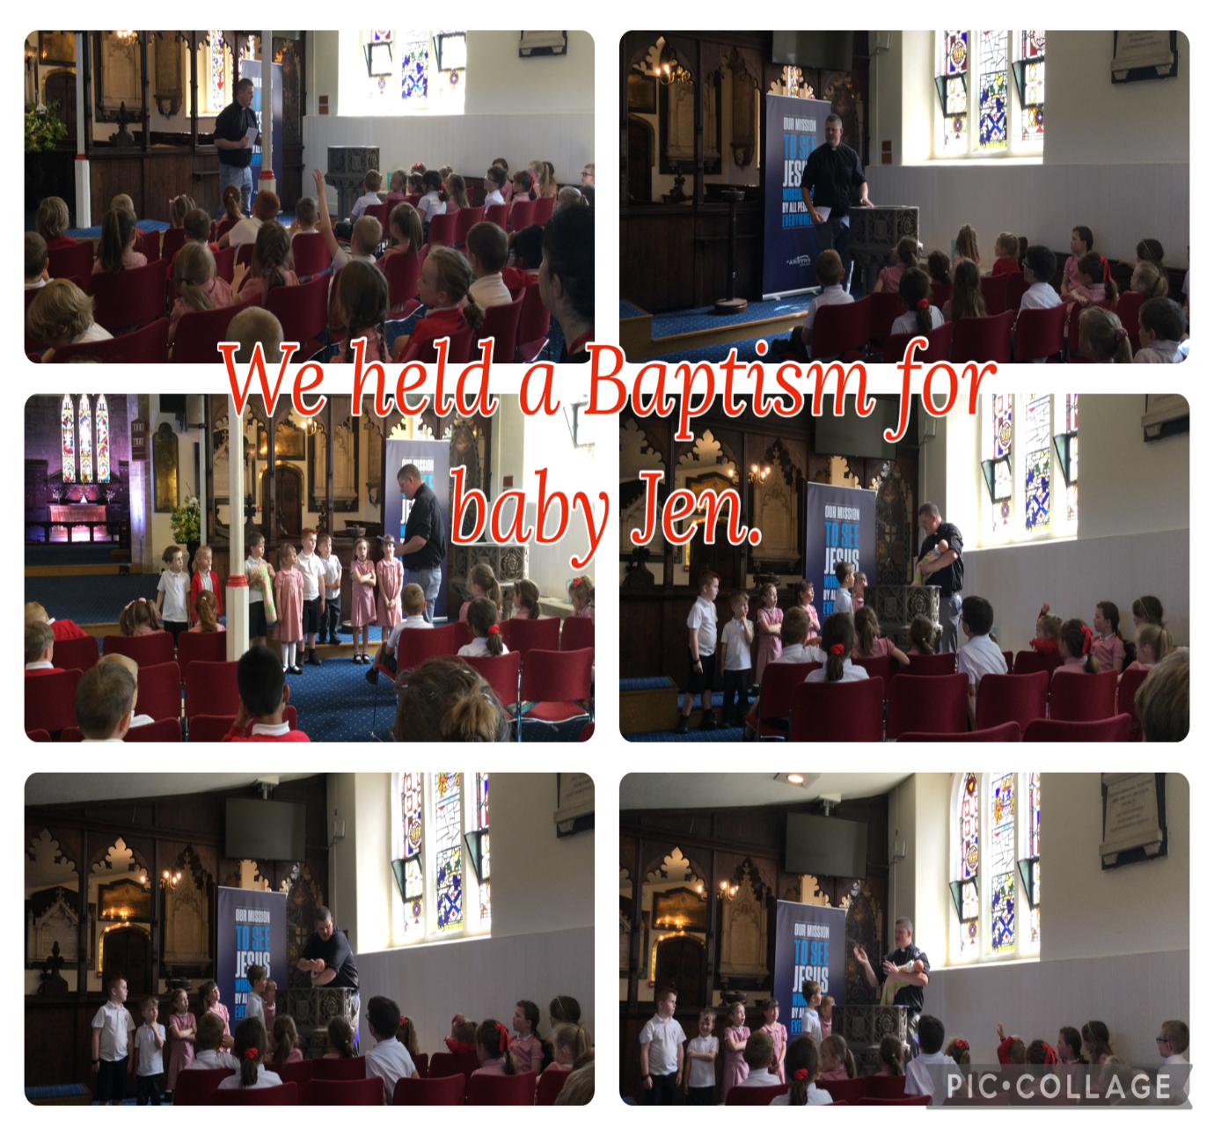

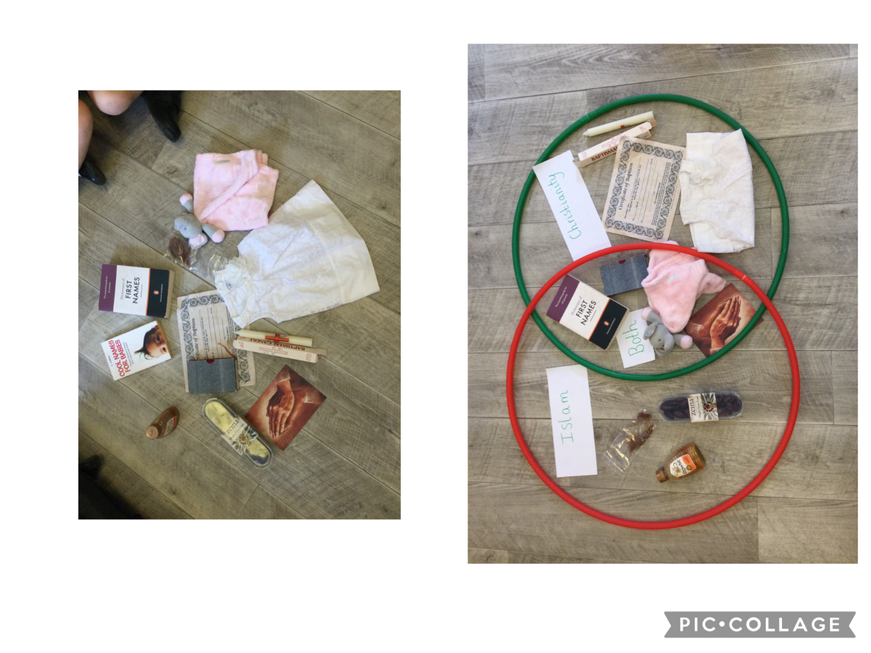

We sorted objects from our Chatterbox into hoops according to whether we thought they are relevant to the Christian Baptism or the Muslim Baptism.