Living Out Our Christian Vision

Owls Class

Here’s how we flourish

Summer 1

PE: We have enjoyed developing our throwing and catching skills and our Cricket Festival.
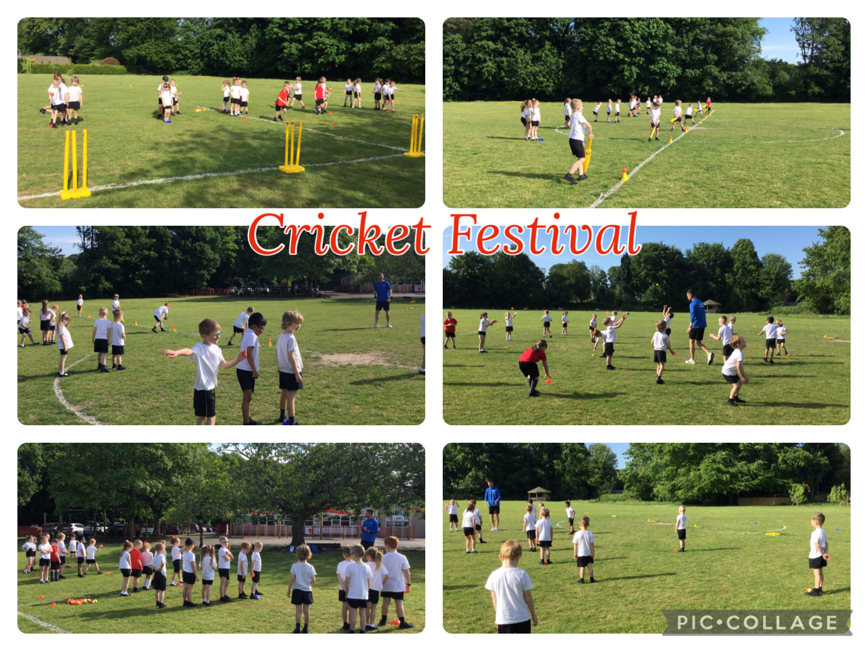

Science: We have looked at different plants and labelling the different parts of the plant.
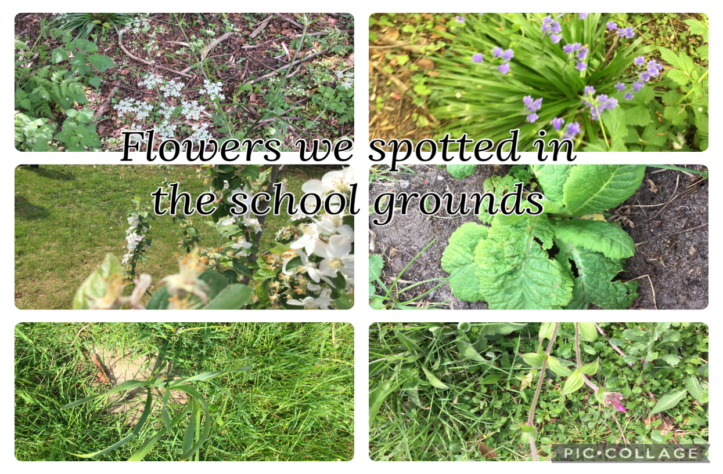
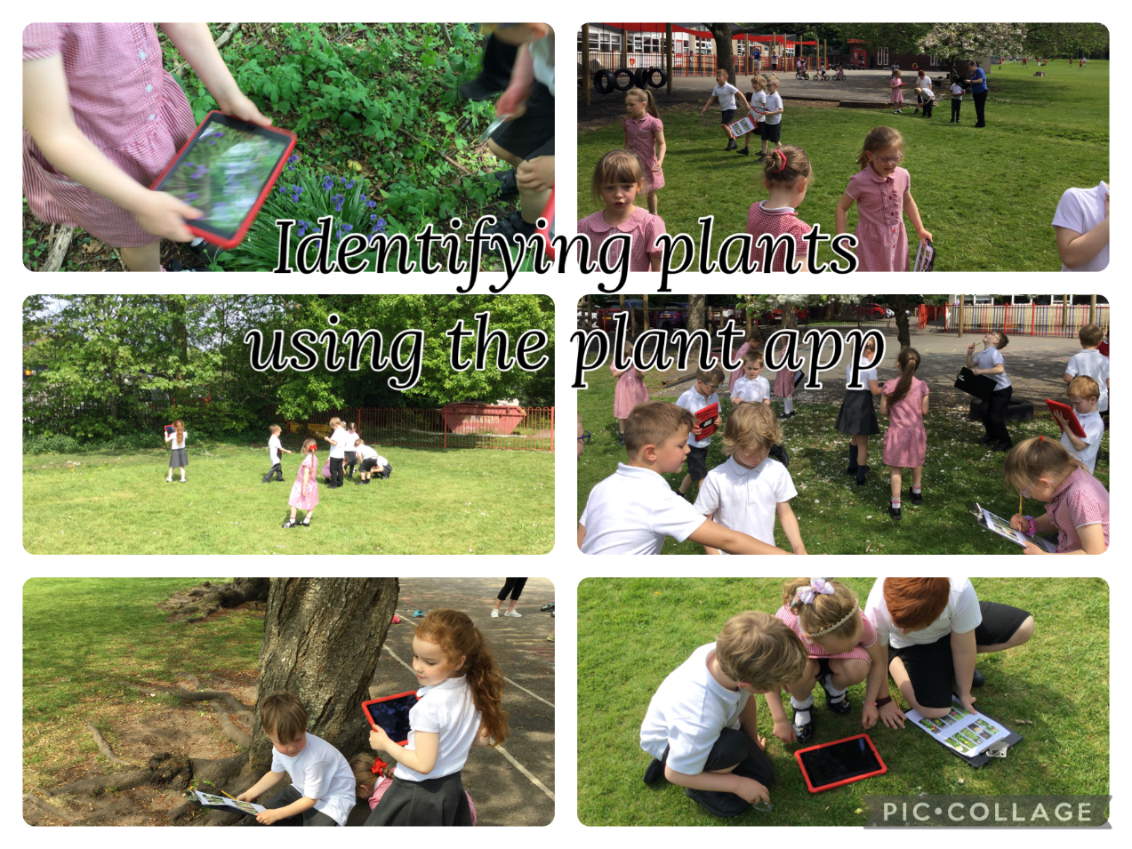
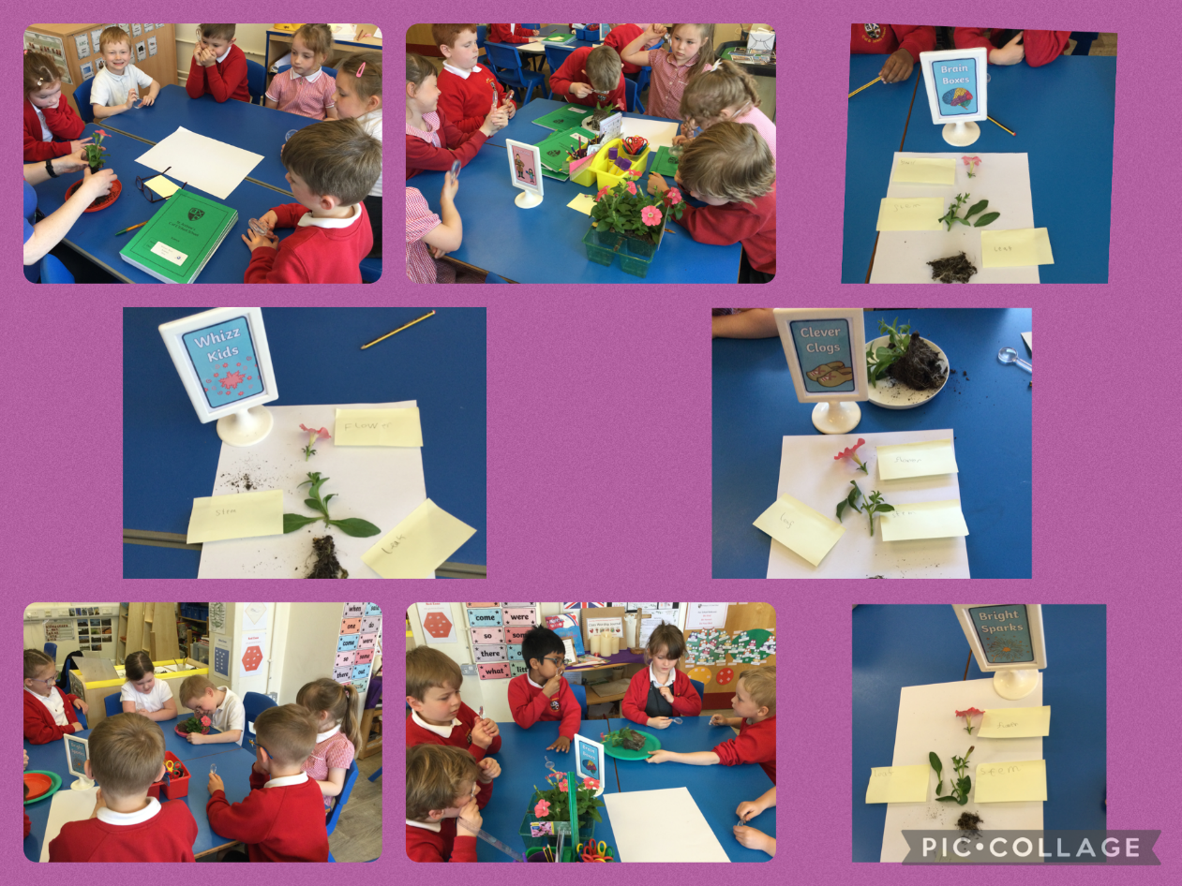

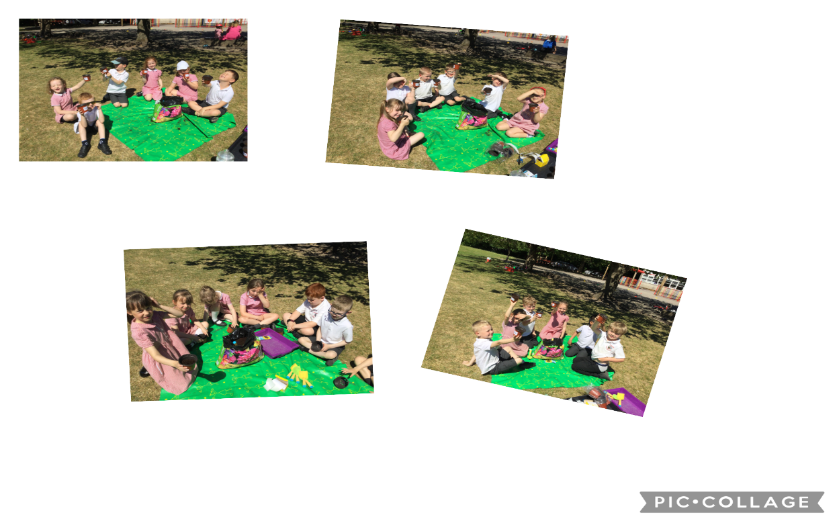
We enjoyed planting our own Sunflowers.

Art: We have enjoyed learning key skills and creating our own landscapes.

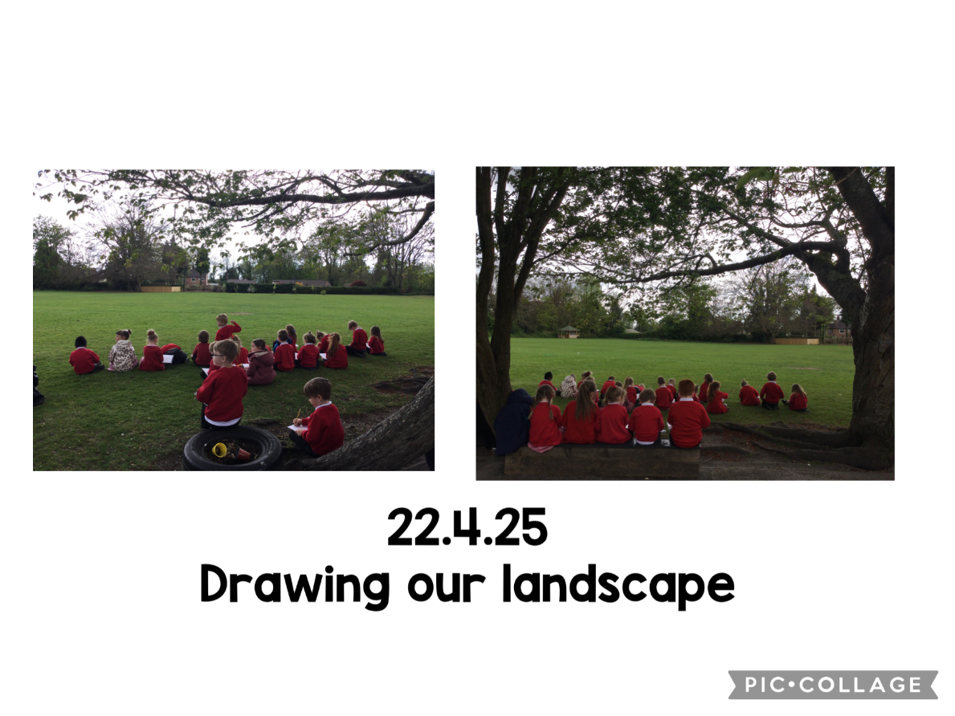
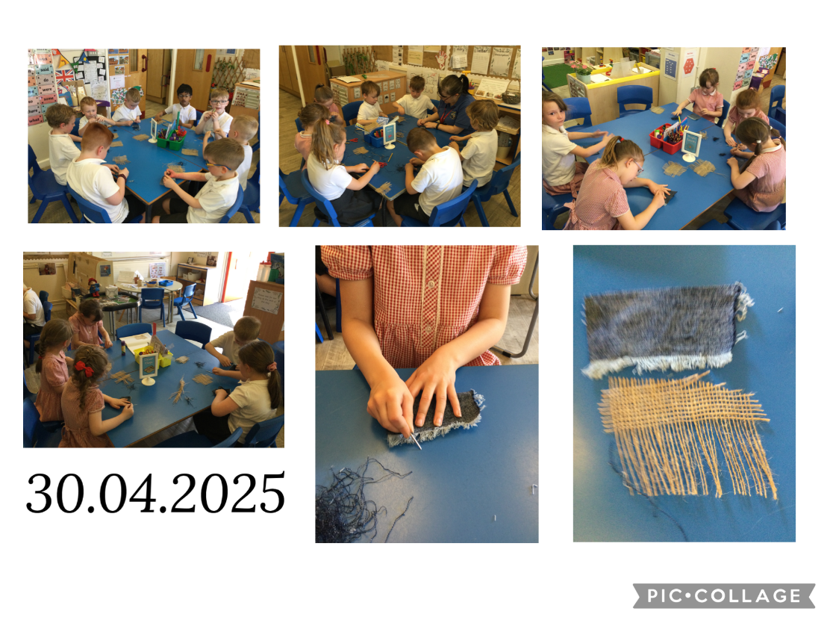
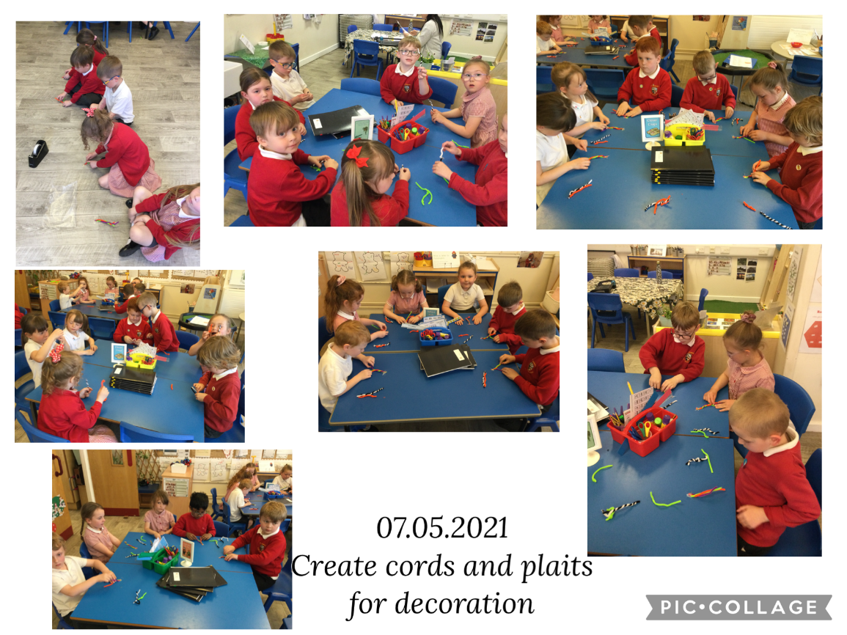

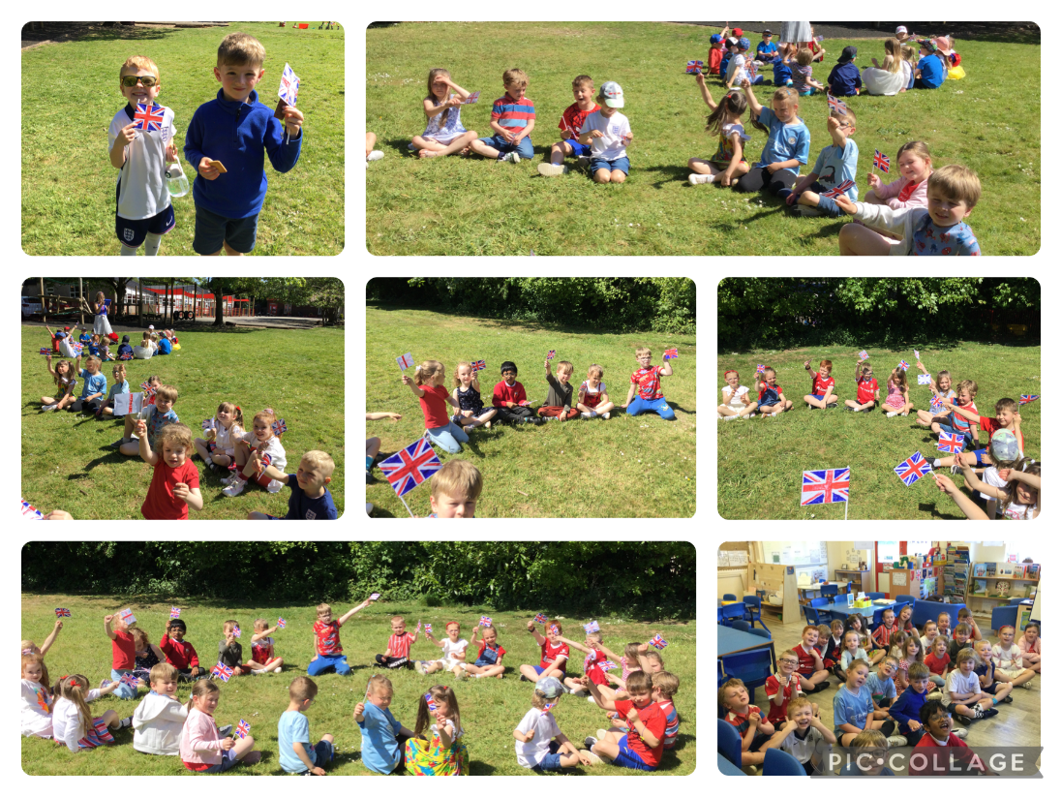

History: We celebrated the VE Day 80 Year Anniversry with activites, music, wearing red, white and blue and an outdoor street party.

PSHRE: We have been looking at how we use money and spending and saving.
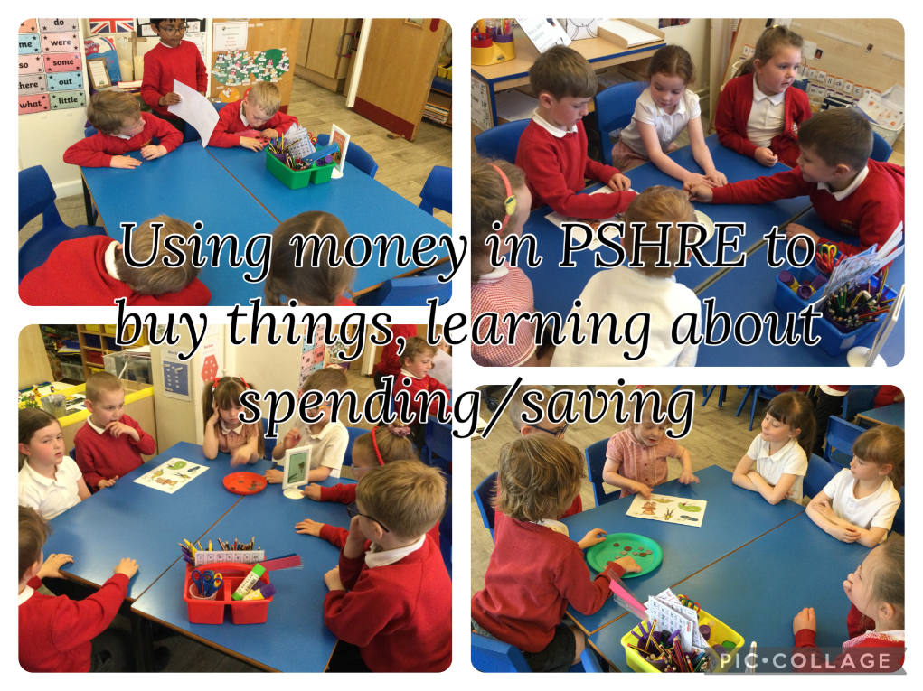
English: We have loved reading Paddington stories and writing about his adventures!

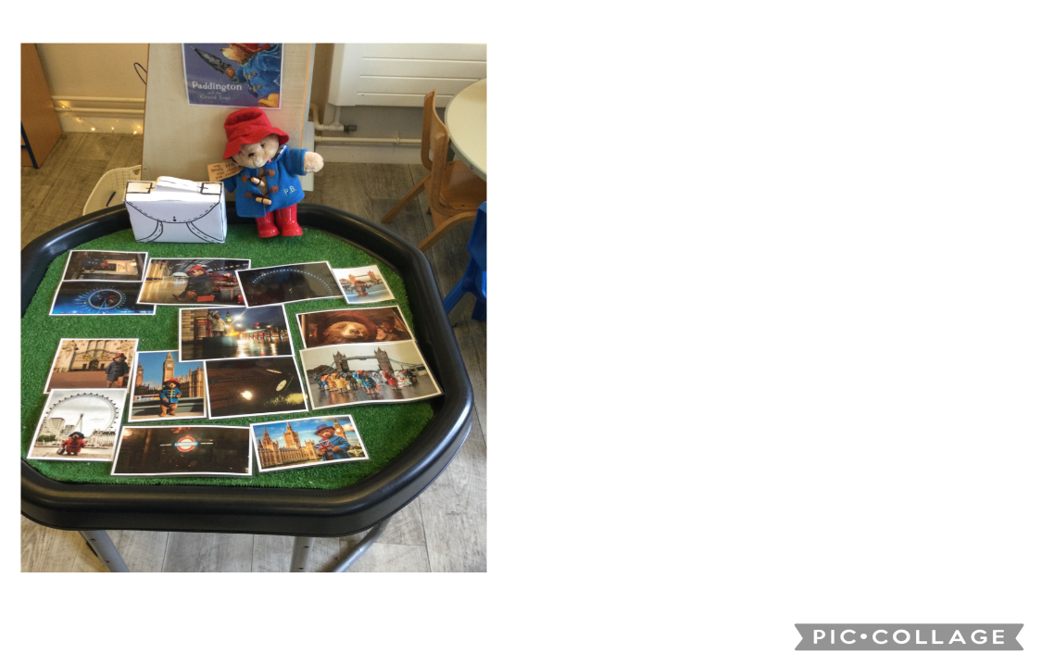
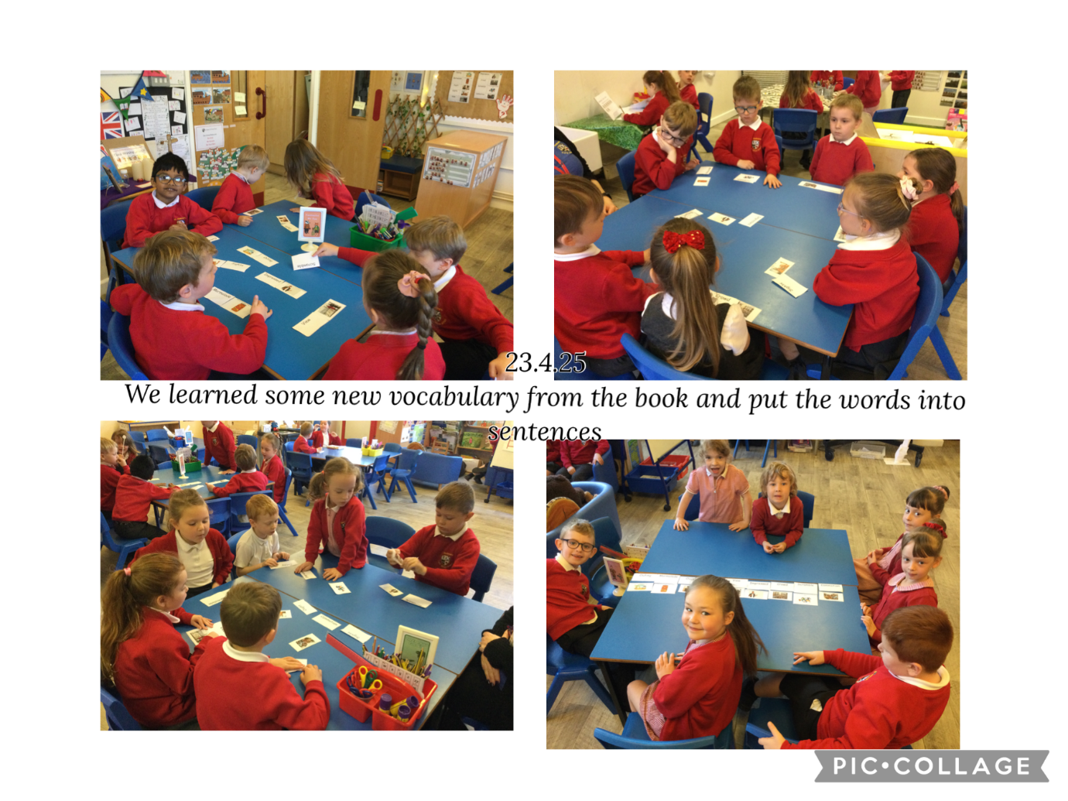
Geography: directions work-using Bee Bot Eric in Gepgraphy to move around the UK map.
