PE Funding

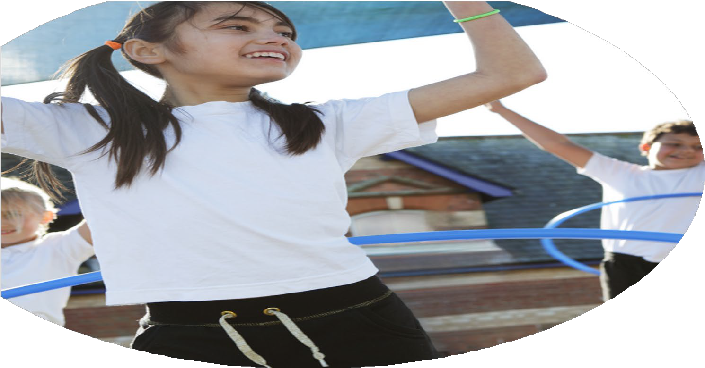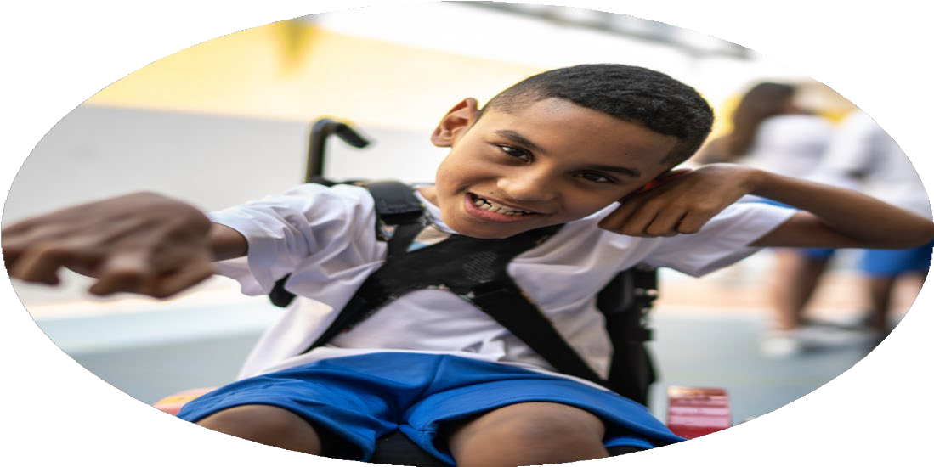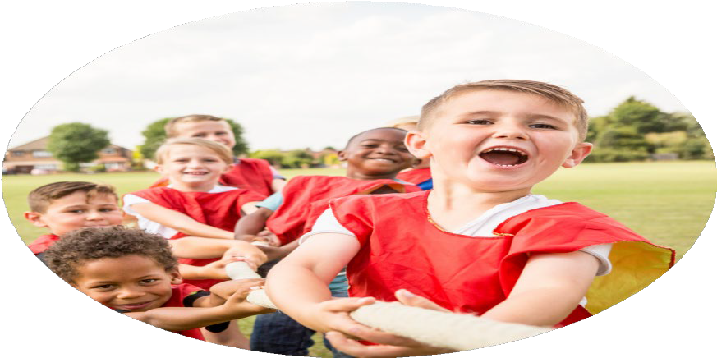

Evaluation Form

**Commissioned by**

**Created by**

Images courtesy of Youth Sport Trust

**PE Funding Evaluation Form**

 It is intended that this template should be used as preparation for the completion of the statutory digital reporting tool being introduced this academic year. You can upload data (including swimming) from this template onto this platform once it becomes accessible.

 Before you decide how you are going to use the funding for this academic year you should reflect and evaluate the impact of your use of the funding in 2023/24.

 All spending of the funding must conform with the terms outlined in the Conditions of Grant document.  The template is a working document that you can amend/update during the year.

 Based on your evaluation of last year’s funding you should decide what you intend to do this academic year, how you will do it, and what impact you expect it to have.

It is important that the funding is used effectively and based on your school’s needs.

 You must use the funding to make additional and sustainable improvements to the PE and sport in your school.  You must develop and add to the PESSPA activities that your school already offers.

*Summative digital reporting from June 2025 will continue to include swimming and water safety information therefore funding can be used to provide top-up lessons where necessary to ensure pupils meet national curriculum swimming requirements.*

**We recommend that you start by reflecting on the impact of current provision and reviewing your previous spend**

|  |  |  |  |
| --- | --- | --- | --- |
| What went well? | How do you know? | What didn’t go well? | How do you know? |
| We introduced trained playtime leaders who set up and facilitated games lunch times. This initiative helped foster leadership skills in older children while providing guidance and support for younger pupils. The younger children have responded positively, demonstrating improved social skills, increased physical activity, and greater confidence in joining in with structured play. The leaders have stickers related to our Christian Values which they love to give out.  Funding was used to purchase a wider variety of play equipment. As a result, more children are active during playtimes, with greater engagement in physical activity outside. The equipment caters to a range of interests and skill levels, which has contributed to an inclusive play environment. E.g. wobble board, football and scooters.  A new outdoor storage shed was installed, providing easy access to equipment for all children. This has encouraged independence and responsibility, as pupils can now choose and return equipment themselves. The increased accessibility has also supported greater participation in physical play, as children have more choices. The playgroup leaders have access to the key.  The PE Passport app has significantly improved our lesson planning and delivery. It offers a progressive, engaging curriculum that ensures all children experience fun and challenging PE sessions. Teachers report increased confidence in delivering high-quality PE lessons, and children are more motivated and excited to take part. We continue to offer a wide range of extra-curricular sports and activity clubs, including dance, gymnastics, and multi-skills. These clubs provide additional opportunities for children to be active beyond the curriculum, with high levels of participation across all year groups. | There has been a noticeable rise in the number of children actively participating in games and physical activities during play and lunch times. Staff have observed more inclusive play and positive interactions, particularly between older playtime leaders and younger pupils.  Children have expressed enjoyment in the variety of playtime equipment and the structured games available. They regularly comment on how much they enjoy using the equipment and having choices in how they play. “I like the boards because they go fast.” (Reception child age 5)  Staff have reported improved behaviour and more purposeful play during break times. There is less conflict and more cooperative play, which we attribute to both the increased resources and the structured support from playtime leaders.  Using the PE Passport app, lessons are now more structured, enjoyable, and challenging, leading to improved skill development and enthusiasm.  We have seen strong attendance and enthusiasm for extra-curricular sports clubs, with many children choosing to attend more than one. This suggests that children are motivated to be active outside of curriculum time. | Due to staff changes during the year, there were some gaps in the assessment and tracking of pupils’ progress in PE. Although lessons continued to be delivered effectively using the PE Passport app.  While the playtime leader initiative had a positive start, a few pupils chose not to continue in their roles as the year progressed. This highlighted the need for ongoing motivation, support, and recognition for pupils taking on leadership responsibilities. Moving forward, we plan to introduce more structured training and regular check-ins to help maintain engagement and commitment. | During internal reviews and staff meetings, it became clear that some assessment data was missing or incomplete, particularly following changes in teaching staff. While lesson delivery remained consistent, the expected assessment records were not always updated, highlighting a need for further training and support in using the PE Passport app for tracking progress.  We monitored participation in the playground leaders and noticed a decline in involvement from some of the children originally trained. Through informal conversations and check-ins, pupils shared that they no longer felt interested or confident in the role. The remaining leaders without a partner chose a friend to help them on their days. |

|  |  |
| --- | --- |
| What are your plans for 2024/25? | How are you going to action and achieve these plans? |
| Intent | Implementation |
| **Ensuring children are active during lunchtimes:**  To ensure the lunchtime trolley is fully stocked for the children.  To ensure the ‘young leaders’ bag is stocked and organised  Choose and train Year 2 ‘Young Leaders in September  To ensure welfare staff take responsibility for allowing access to the shed outside  Yoga lunchtime Club  **To embed the PE curriculum:**  Train new staff  Evidence collected via PE PASSPORT  PE lead updates  Ensure effective use of PE PASSPORT  Ensure effective assessment is collected  **To provide a variety of extracurricular activities:**  To ensure that we have clear communication with parents about South Ribble After School clubs.  Yoga lunchtime Club  Book various other clubs throughout the year  Pupil premium participation in clubs  Add pupils on to PE PASSPORT Club to monitor  **To develop more inclusive participation in physical activity for SEND/PP children** | To order new resources for the lunchtime trolley.  Order resources when needed throughout the year  New bag arrives 9th Oct  Training on 9th October  5 children from each year 2 class  Access to key  RM to show them the games folder and stickers  Explain young leaders once implemented  10 children attend zoom yoga for half a term  Training videos online  Support from PE lead and Year group teachers  Selected children renamed and evidenced collected  PE lead attend training 15th October  Evidence – Gold, silver and bronze children identified – evidence collected  All staff assess all children at the end of each half term/unit of work  Contact (South Ribble) regularly – clear communication with parents  10 children attend zoom yoga  Zumba  Year 2 Football  Monitor which children do which clubs  No of PP children accessing clubs  Book Amir (visually impaired Olympic footballer) for a whole school football day  Invite PP and SEN to clubs |

|  |  |
| --- | --- |
| What impact/intended impact/sustainability are you  expecting? | How will you know? What **evidence** do you have or  expect to have? |
| By ensuring the lunchtime trolley and Young Leaders’ resources are well-stocked and organised, children are provided with a variety of engaging activities. The selection and training of Year 2 Young Leaders in Autumn term ensures that pupil leadership is sustainable and embedded within the school culture.  **Intended Impact:** Increased levels of physical activity, improved pupil behaviour and social interaction during lunchtimes and playtimes. **Sustainability:** Activity pack and resources reused and added to.  Ongoing training for new staff and regular updates by the PE lead ensure consistency in PE delivery. The use of PE PASSPORT helps structure lessons, track assessment, and evidence progression. **Intended Impact:** Higher quality PE lessons, improved teacher confidence and subject knowledge, and clear monitoring of pupil progress. **Sustainability:** Once staff are trained and confident with PE PASSPORT, quality provision is maintained year on year. Resources are reusable and assessments provide long-term data tracking.  Clubs such as yoga and externally delivered South Ribble clubs provide diverse opportunities for children to explore different types of physical activity. Booking a range of clubs throughout the year encourages sustained interest and engagement. Monitoring participation, especially among pupil premium children, ensures inclusivity. **Intended Impact:** Increased participation in physical activity, especially among children who may not be active outside of school. Improved physical and mental well-being. **Sustainability:** Developing a calendar of rotating clubs and fostering partnerships with external providers helps maintain variety and interest. Communication with parents supports ongoing engagement.  By monitoring pupil premium participation and using assessment tools like PE PASSPORT to identify and support less active or SEND pupils, the school is actively promoting inclusivity. **Intended Impact:** Narrowing the gap in physical activity levels between SEND/PP and non-PP peers. Enhanced self-esteem and confidence for all pupils. **Sustainability:** Establishing targeted support systems to improve provision continuously. | * + Observations of lunchtime activities showing high levels of pupil engagement.   + Pupil voice surveys or informal feedback showing enjoyment.   + PE PASSPORT data showing lesson plans, assessment records, and pupil progress across year groups.   + CPD for PE lead – PE PASSPORT refresher   + PE lead termly monitoring records.   + Consistency and progression visible in children's PE skills across the school.   + Pupil voice via PE PASSPORT   + Club registers showing attendance across different terms and year groups via PE PASSPORT   + Records of South Ribble club delivery and communication with parents.   + Photos and displays of children participating in clubs via the website   + Invitations, encouragement letters for clubs or activities for SEN and PP children   + Positive feedback from children, staff and parents regarding our football day with Amir an Paralympian Footballer |

|  |  |
| --- | --- |
| What **impact/sustainability** have you seen? | What **evidence** do you have? |
| **Ensuring children are active during lunchtimes:** **Impact:** Increased levels of physical activity, improved pupil behaviour and social interaction during lunchtimes and playtimes. **Sustainability:** Activity pack and resources reused and added to.  **To embed the PE curriculum:** **Impact:** Higher quality PE lessons, improved teacher confidence and subject knowledge, and clear monitoring of pupil progress in most classes. **Sustainability:** Once staff are trained and confident with PE PASSPORT, quality provision is maintained year on year. Resources are reusable and assessments provide long-term data tracking.  **To provide a variety of extracurricular activities:** **Impact:** Increased participation in physical activity, especially among children who may not be active outside of school. Improved physical and mental well-being. **Sustainability:** Developing a calendar of rotating clubs and fostering partnerships with external providers helps maintain variety and interest. Communication with parents supports ongoing engagement.  **To develop more inclusive participation in physical activity for SEND/PP children** **Impact:** Narrowing the gap in physical activity levels between SEND/PP and non-PP peers. Enhanced self-esteem and confidence for all pupils. **Sustainability:** Continue to ‘invite’ pupils to clubs free of charge. More influential sports events e.g. Amir expressed numerous activities that promote his ethos of inclusivity. | * + Observations of lunchtime activities showing high levels of pupil engagement.   + Pupil voice surveys or informal feedback showing enjoyment and activity.   + PE PASSPORT data showing lesson plans, assessment records, and pupil progress across year groups.   + CPD for PE lead – PE PASSPORT refresher 11th Feb   + CPD for staff by PE lead for PE PASSPORT during staff meeting   + Subject lead attended PE conference 27th June   + PE lead termly monitoring records.   + Consistency and progression visible in children's PE skills across the school.   + Pupil voice via PE PASSPORT (see app)   + Club registers showing attendance across different terms and year groups via PE PASSPORT   + Records of South Ribble club delivery and communication with parents.   + Photos and displays of children participating in clubs via the website   + Invitations, encouragement letters for clubs or activities for SEN and PP children   + 100% of pupils were PP for our lunchtime yoga club   + More participation this academic year for PP children.   + Positive feedback from children, staff and parents regarding our football day with Amir an Paralympian Footballer. Photos on class dojos. |