**Living Out Our Christian Vision**

**Owls Class**

***Here’s how we flourish***

**Summer 2**

PE: We have enjoyed developing our Rugby skills during our Rugby Festival.

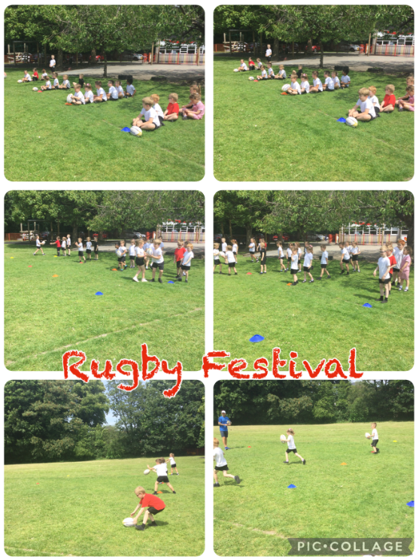

Science: We have looked at different animals and their groupings.

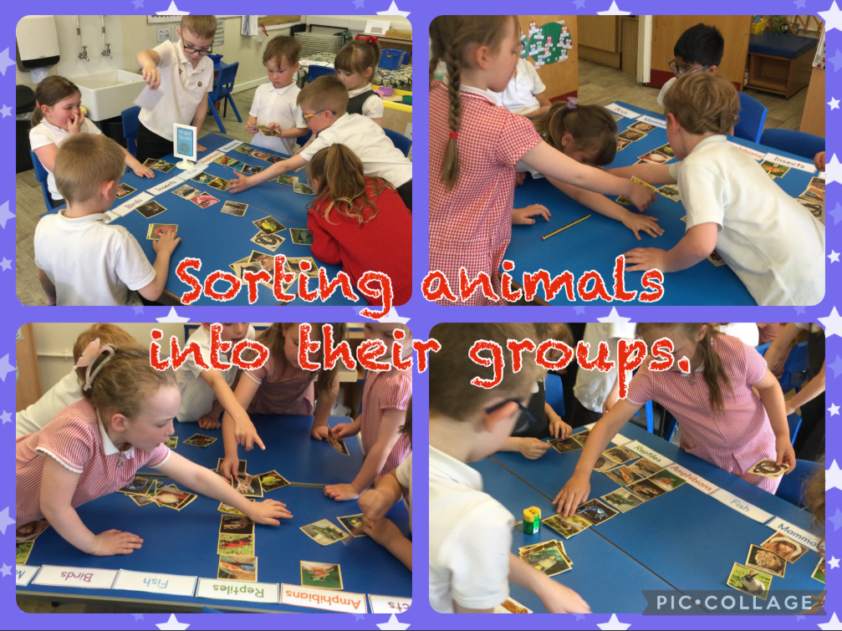

We had a fantastic time on our school trip to Blackpool Zoo, learning more about animals, their food, habitats and behaviours.

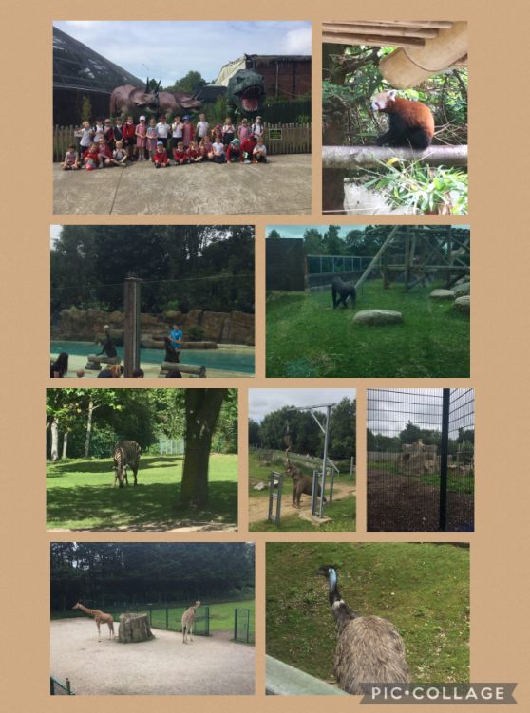

Art: We have enjoyed learning about how to draw animals and how to make a clay model of an animal.

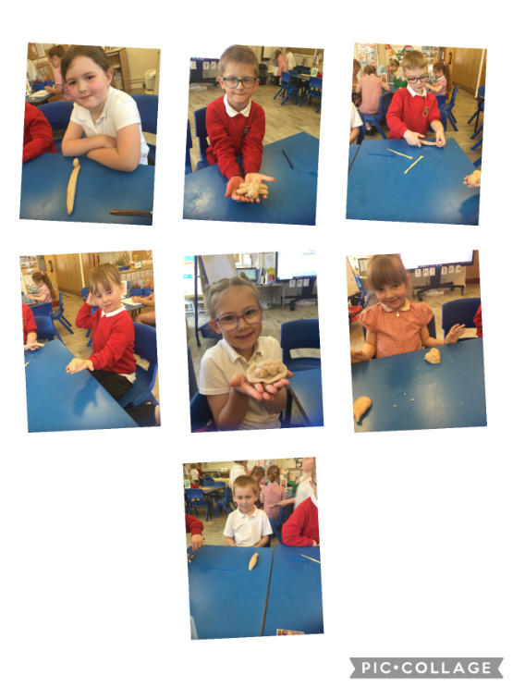

Geography: We have been learning about hot and cold places around the world. We have looked at the Equator and the hemispheres.

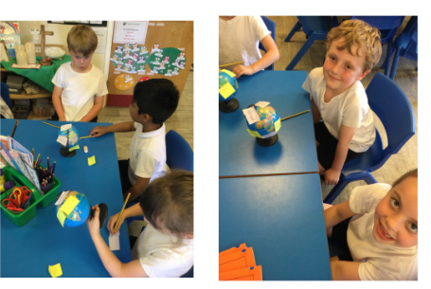

PSHRE: We have been looking at how we can keep safe and what to do in different scenarios.

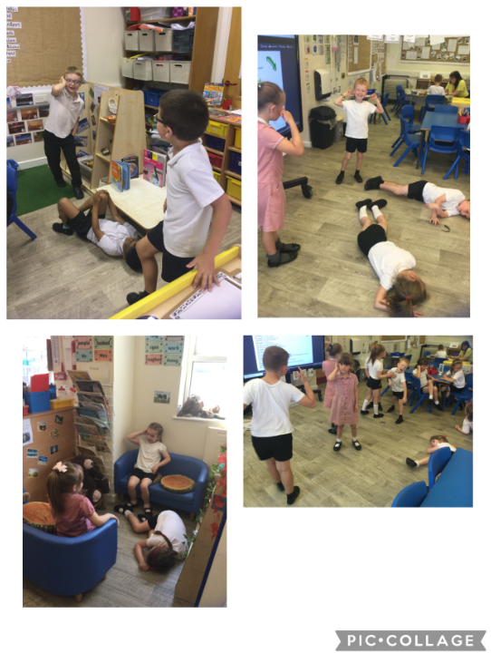

English: We have loved reading about the Lion and the Mouse and writing reports on animals that live in hot and cold places.

