**RE Blog**

**Owls Class**

**Summer 2 – My World, Jesus’ World**

We have been learning about Jesus’ World. We learned about what it was like for Jesus as a Jew and looked at food, transport, clothing, Bible stories etc and compared it to our world. We have noticed some similarities and some differences between Jesus’ world and our world.

Clothing-Jesus’ World/Our World

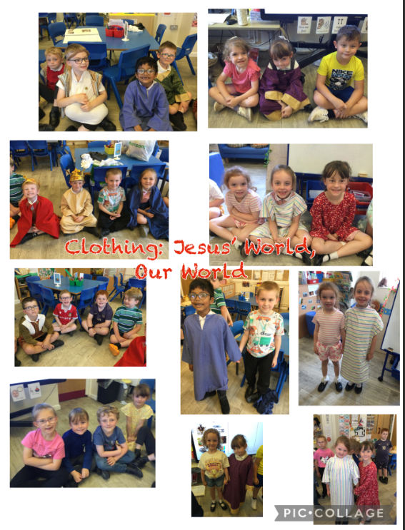

Food-Jesus’ World

We tasted food that would have been common at the time Jesus lived e.g. dates, olives and pitta bread. The children had mixed opinions on the foods!

