Living Out Our Christian Vision

Butterflies Class

Here’s how we flourish

Summer 2
In English we inovated the story of the Lion and the Mouse and made a non-chronological report about animals…..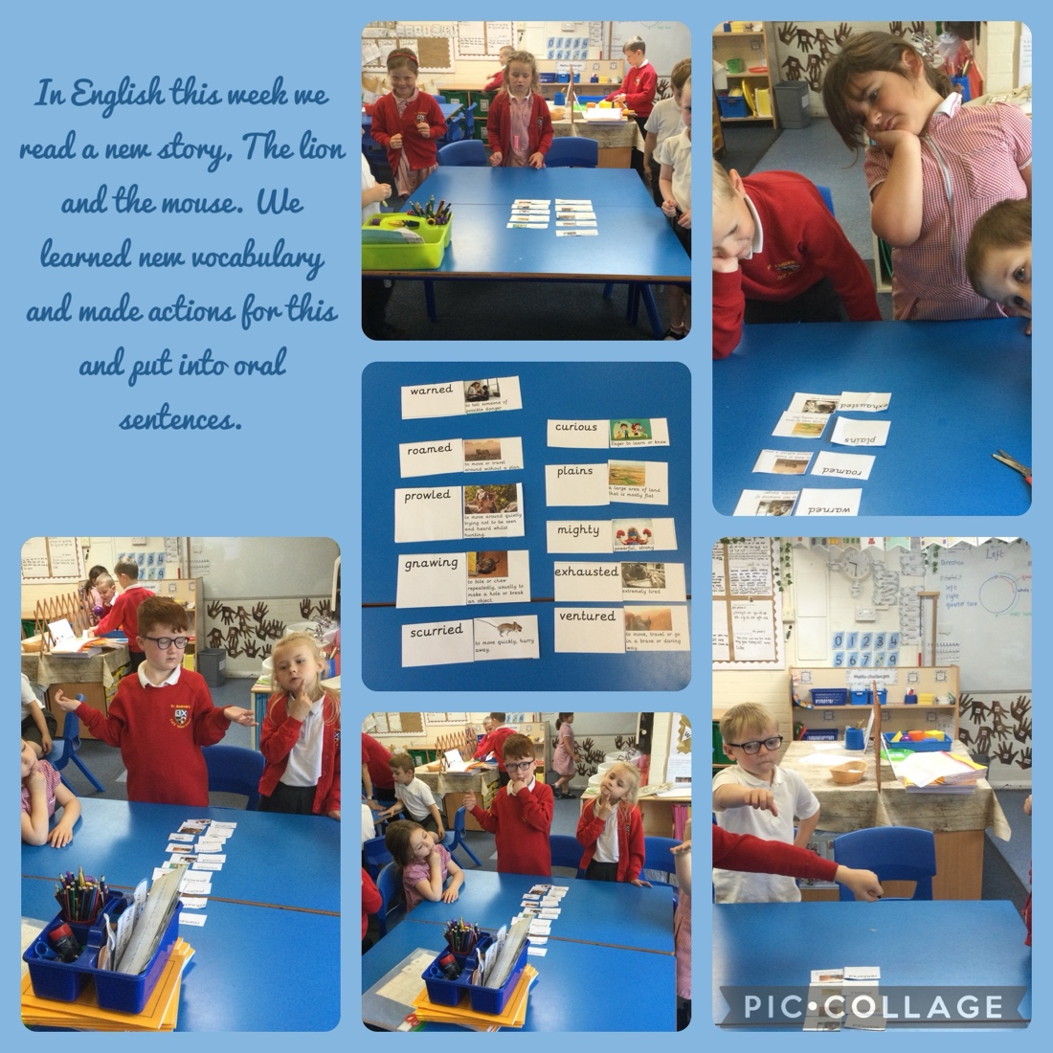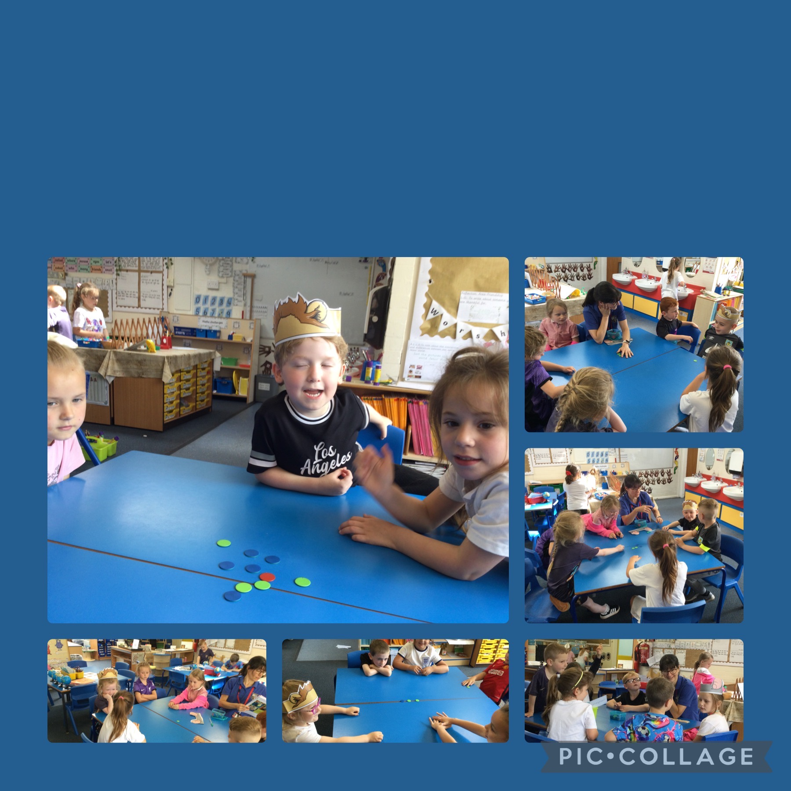

Using our oracy skills during an English lesson whilst getting into character and asking each other questions.

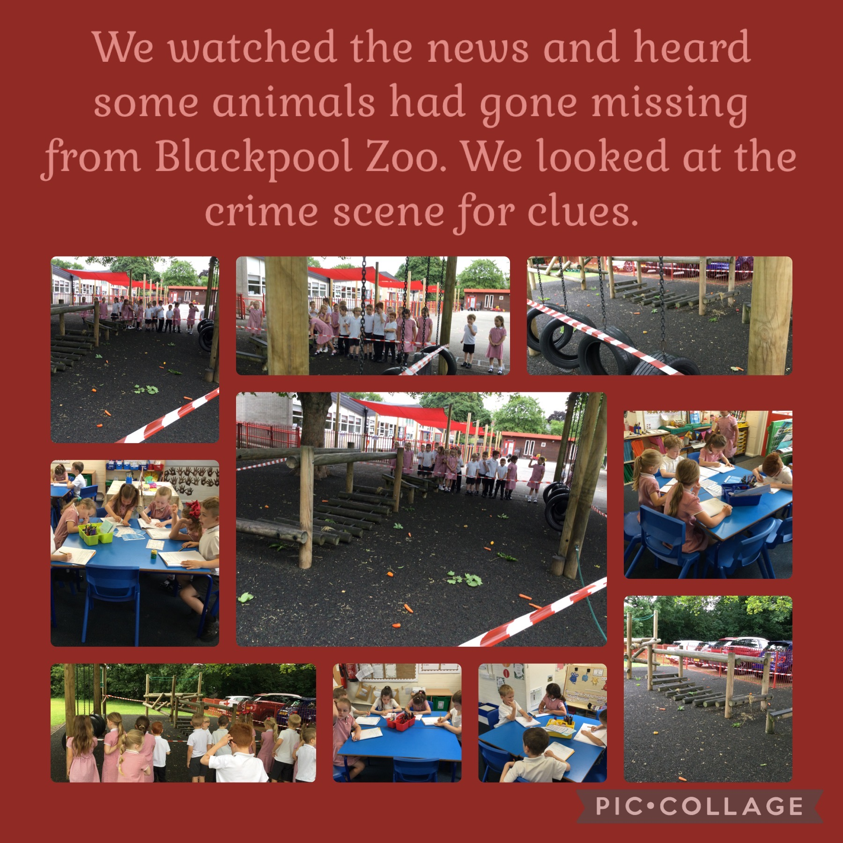

Then we wrote letters to Blackpool zoo to tell them what we found!

In maths we learnt lots of things including addition, subtraction and fractions. Here we are solving mass problems.

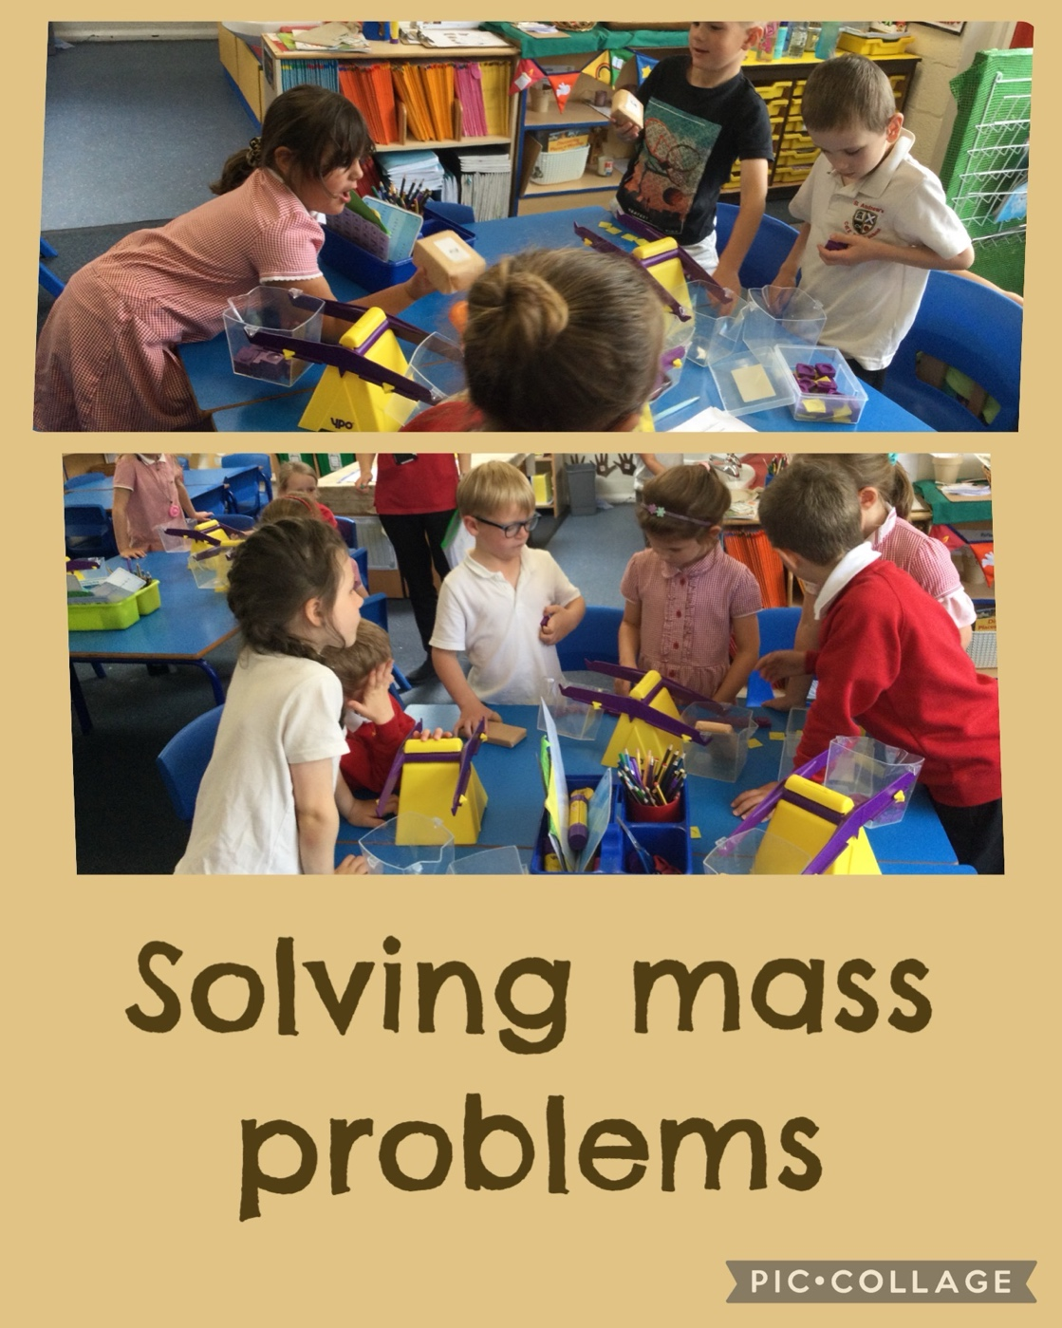

In Science we learnt all about plants and we looked at the season Summer…..

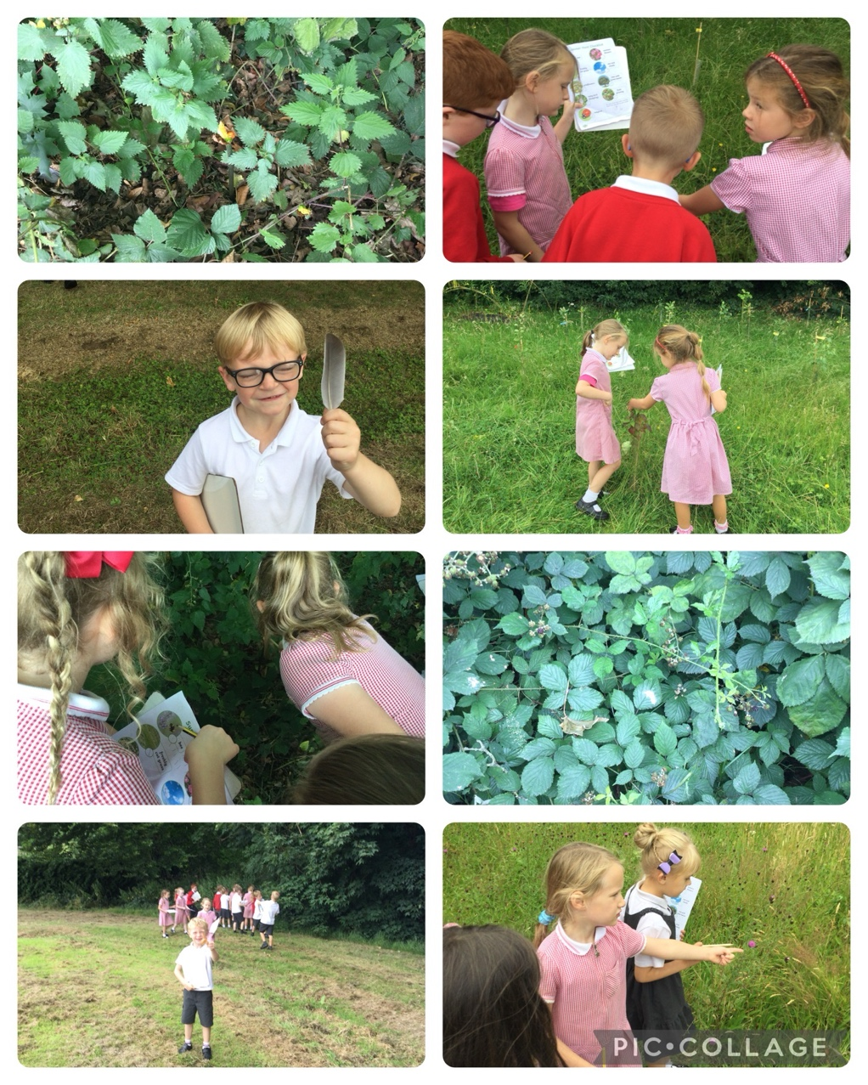

In Geography we learnt about hot and cold places around the world.
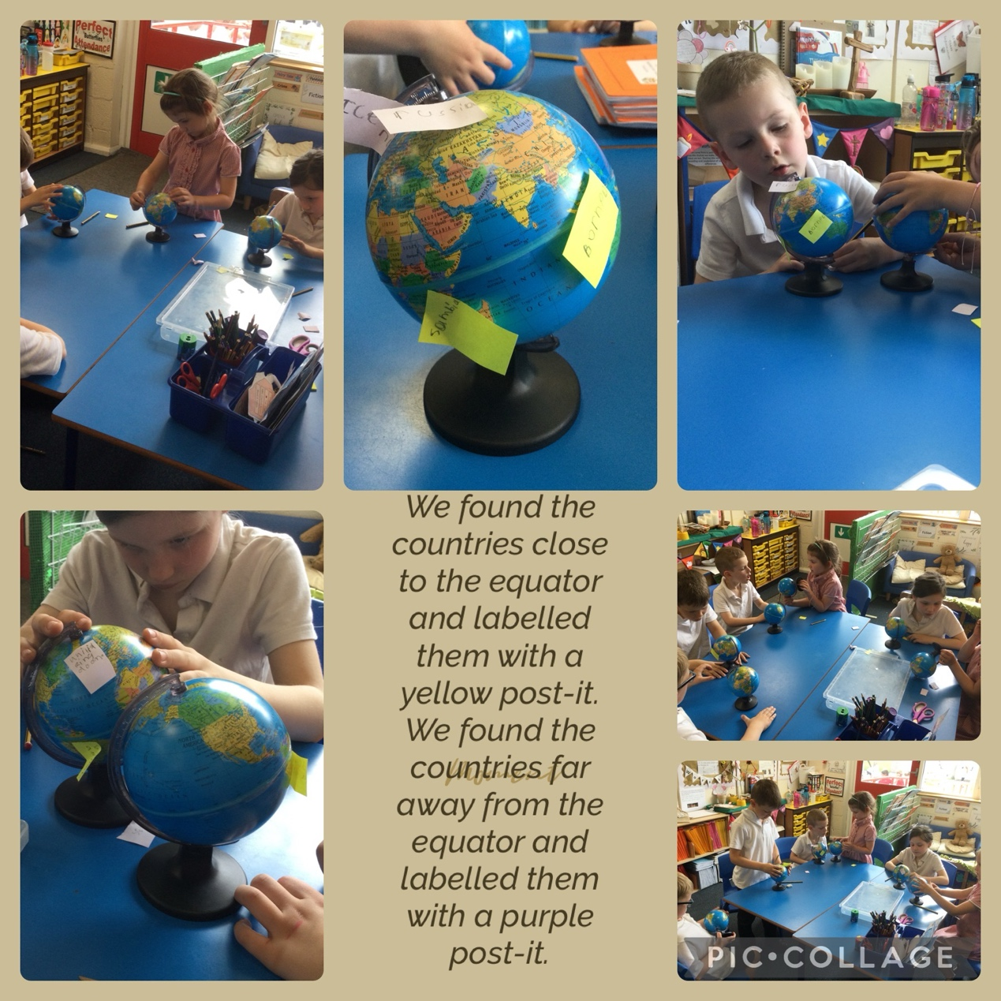
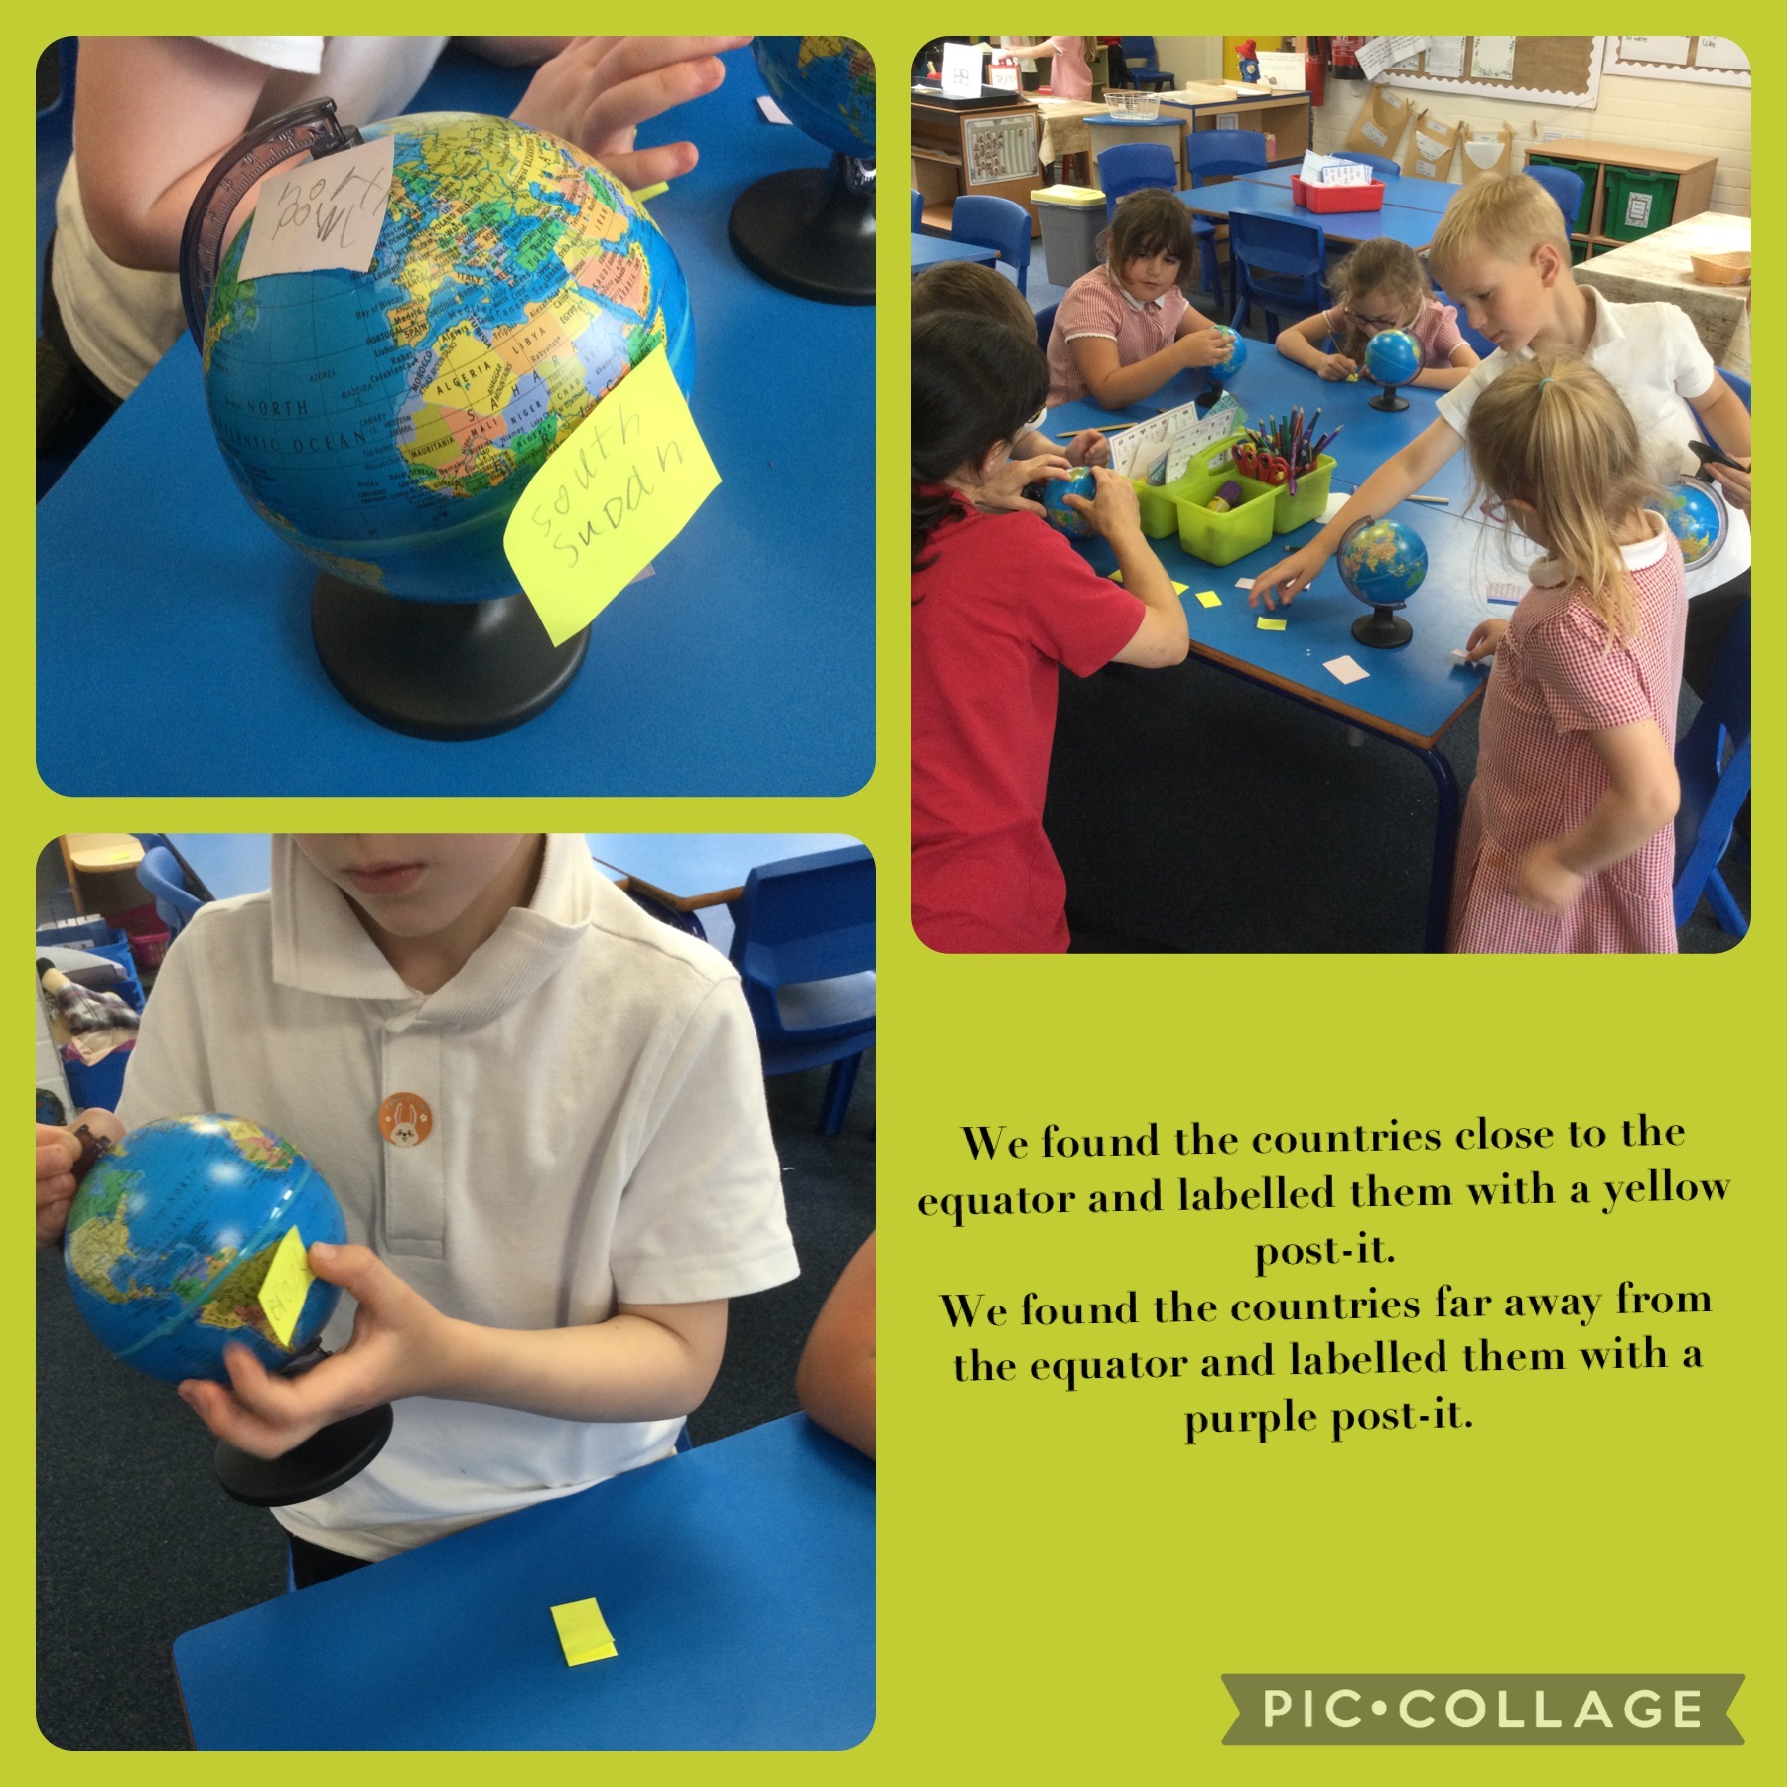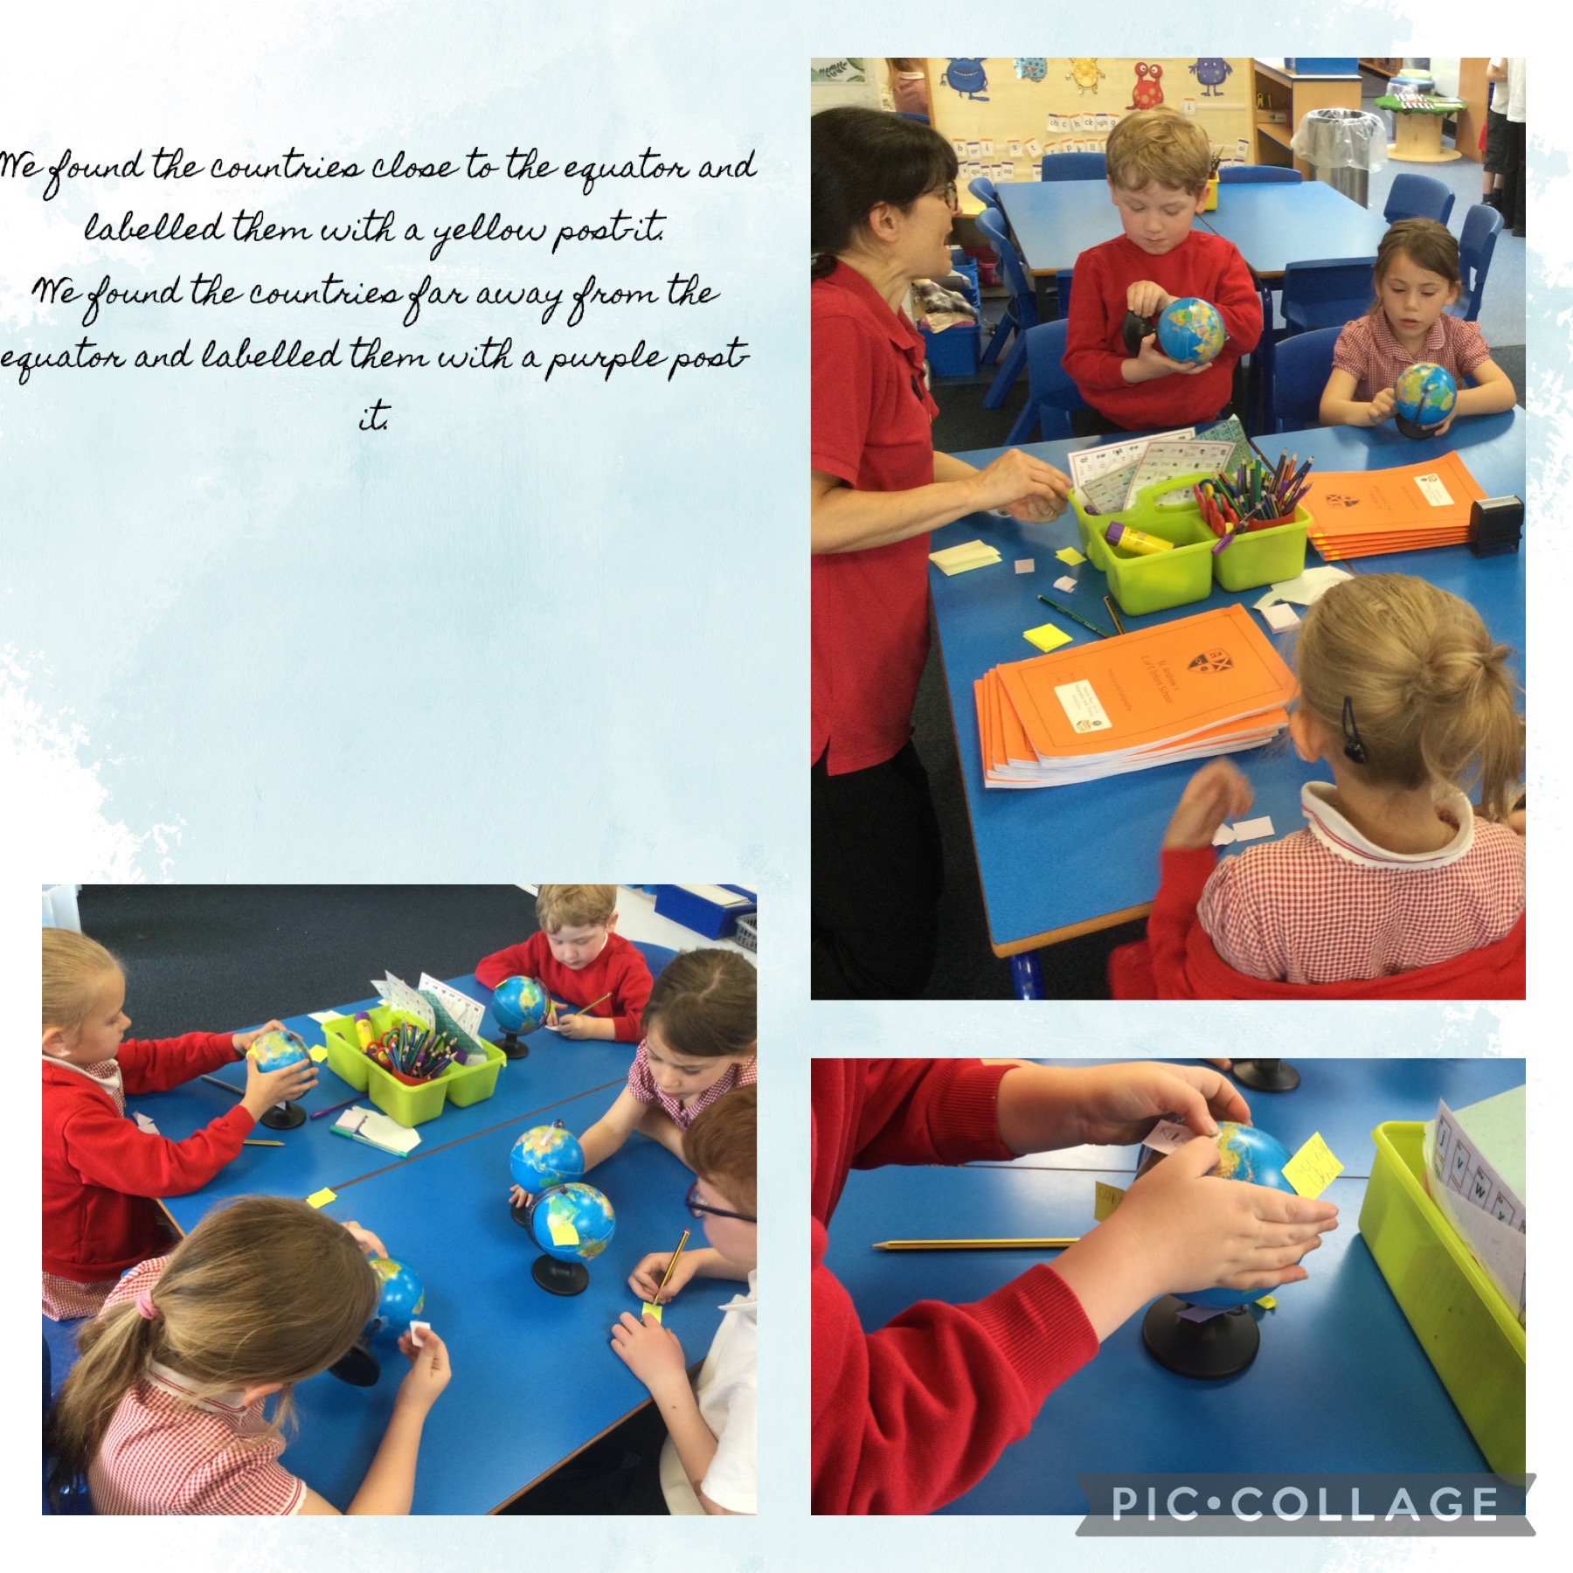

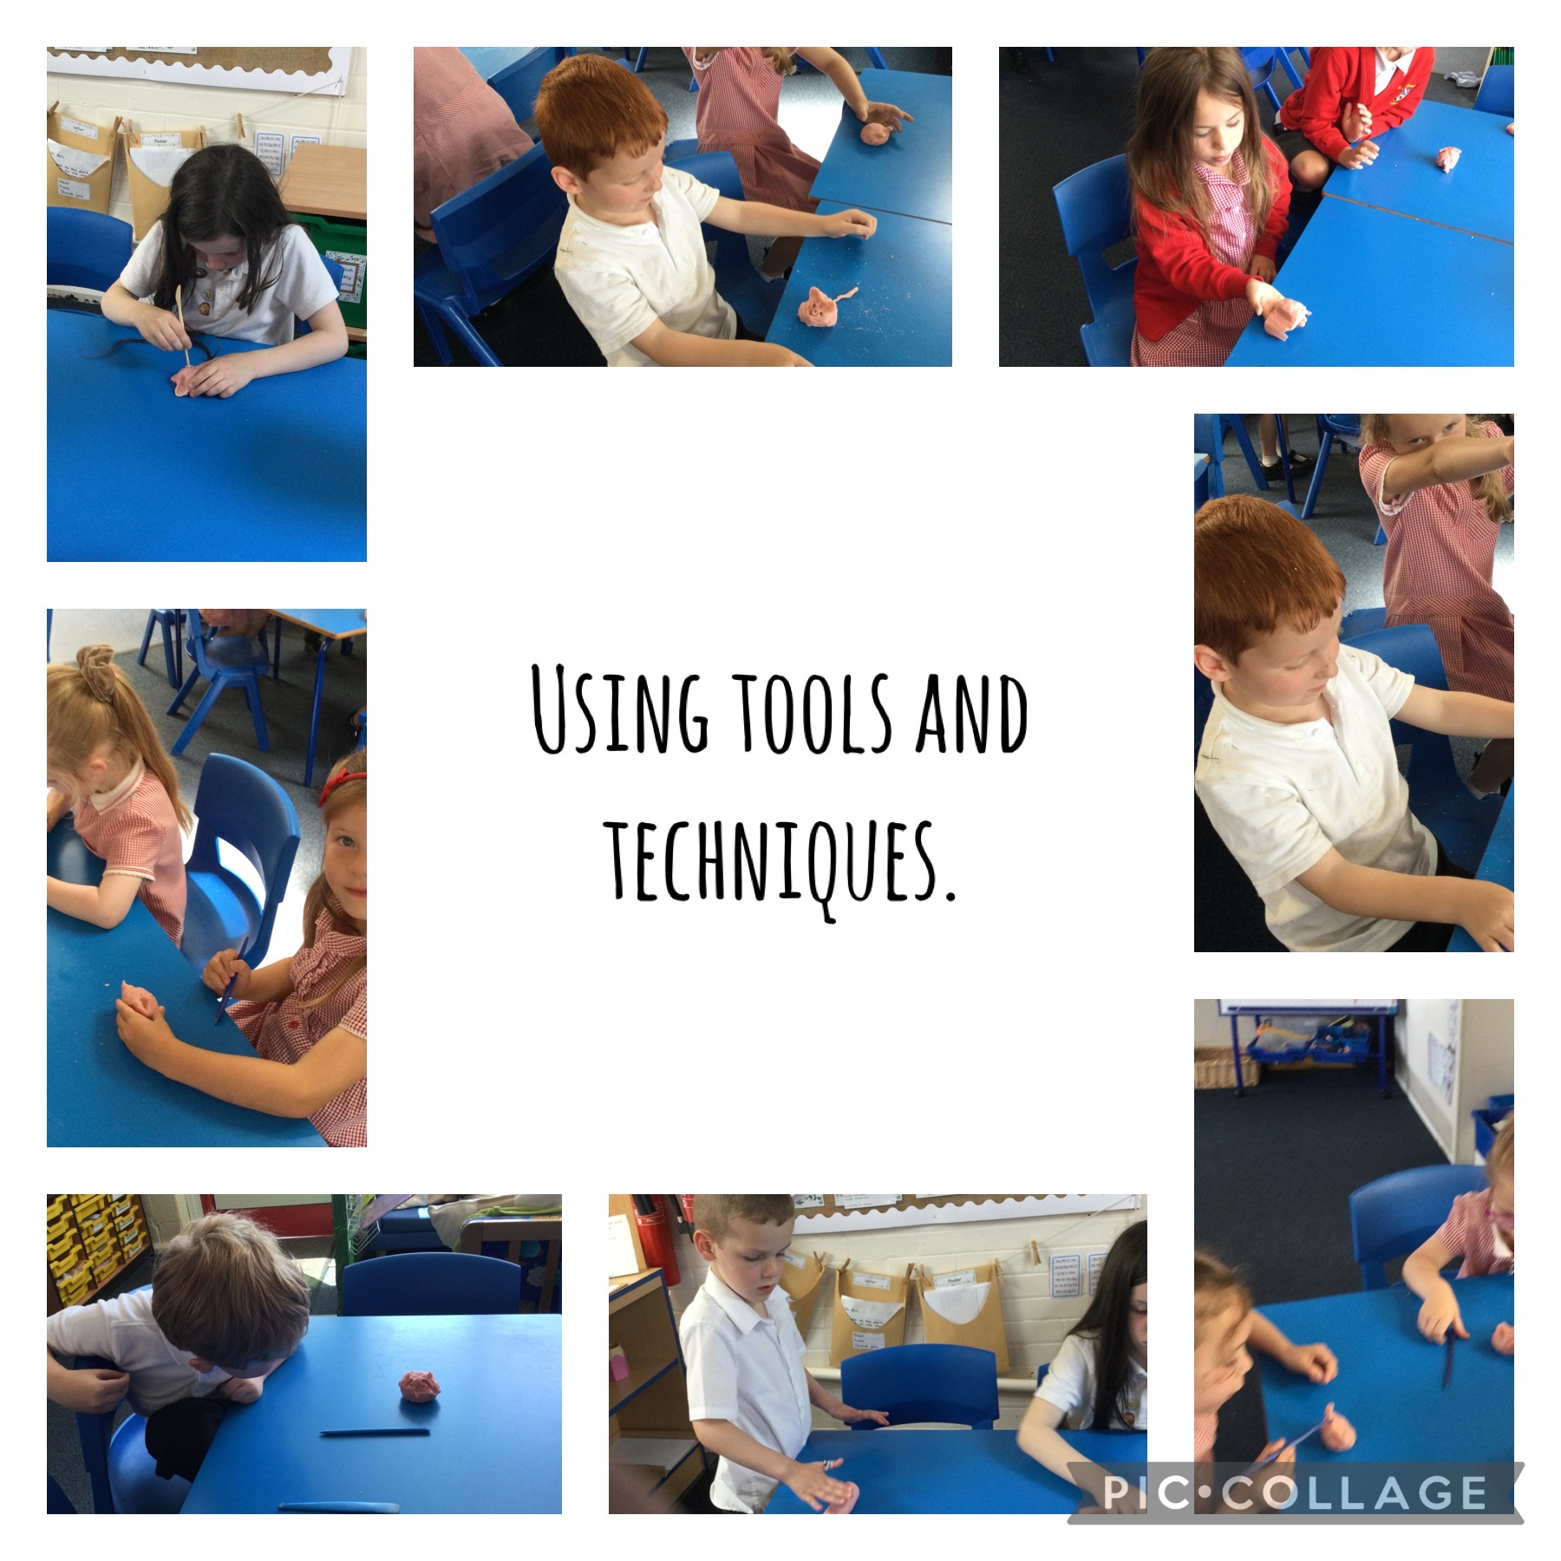
In Art we made animals from Clay….
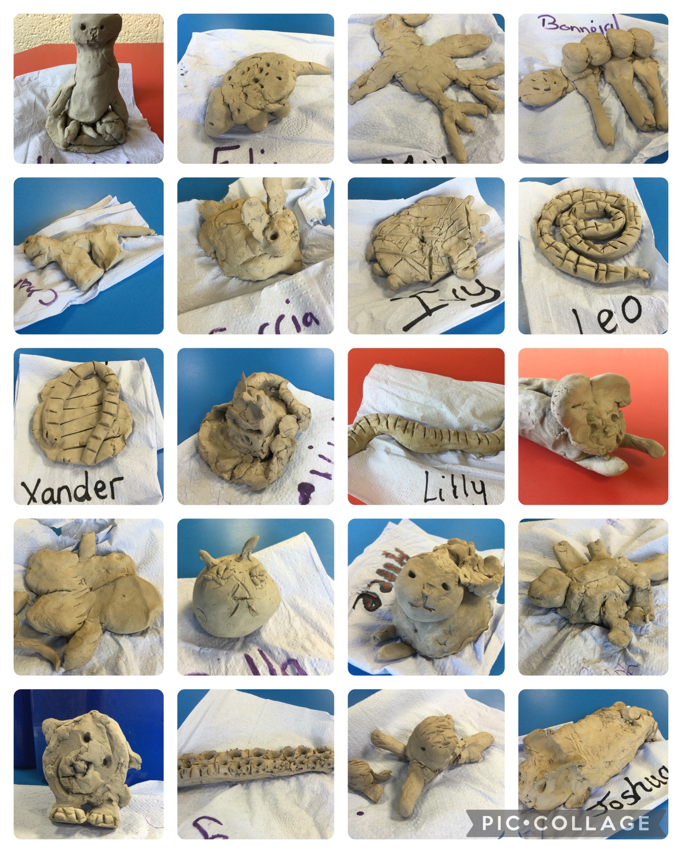
In PSHRE we learnt about people who keep us safe……

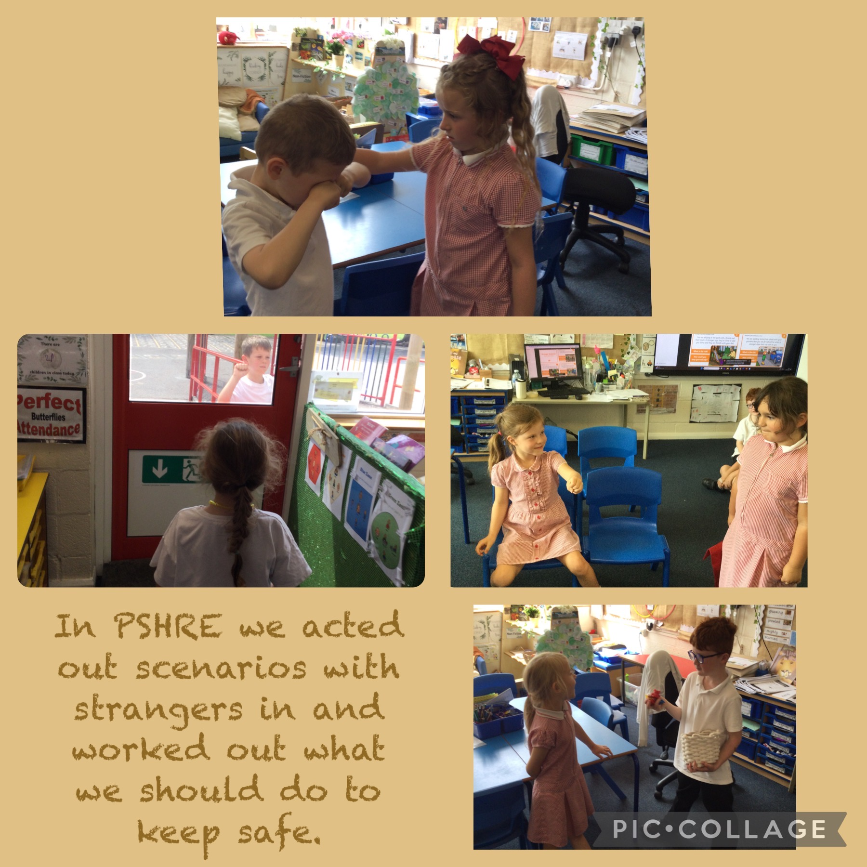

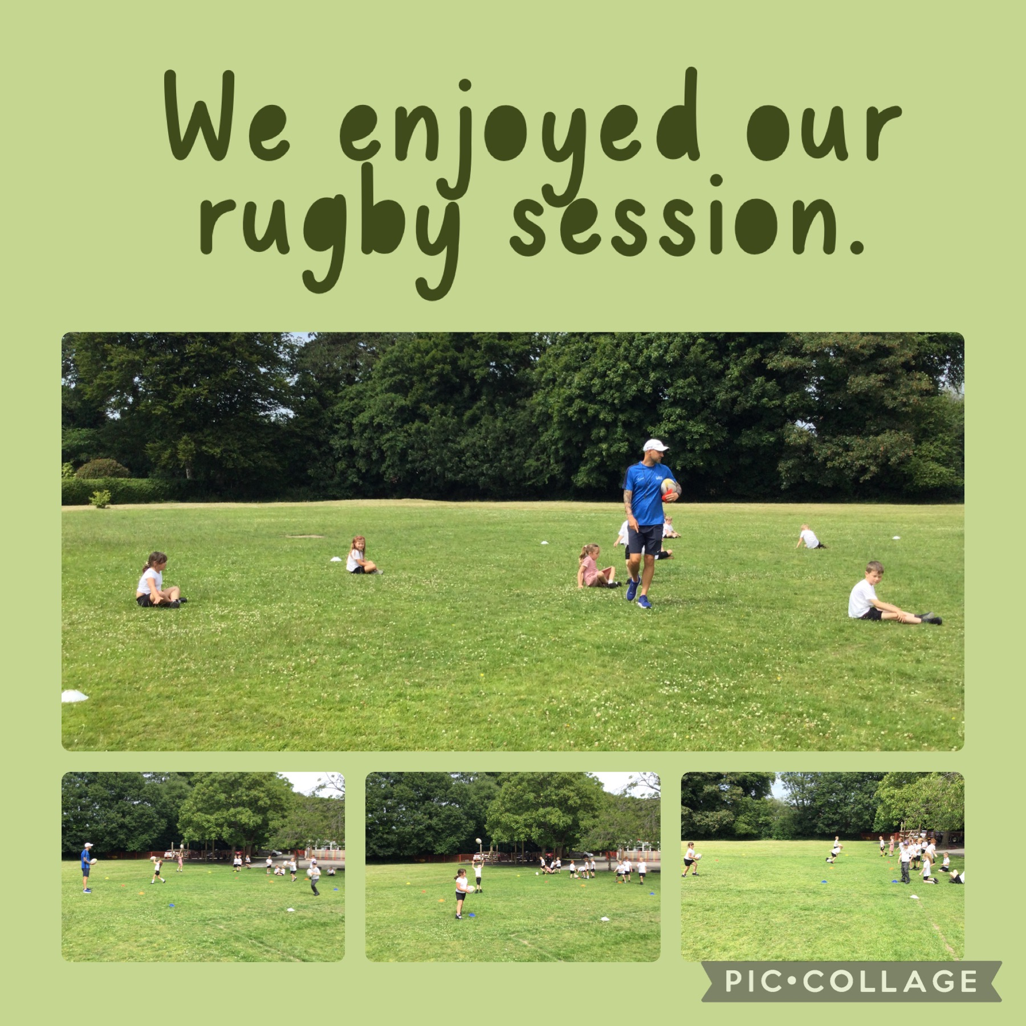

We enjoyed our trip to the zoo…..
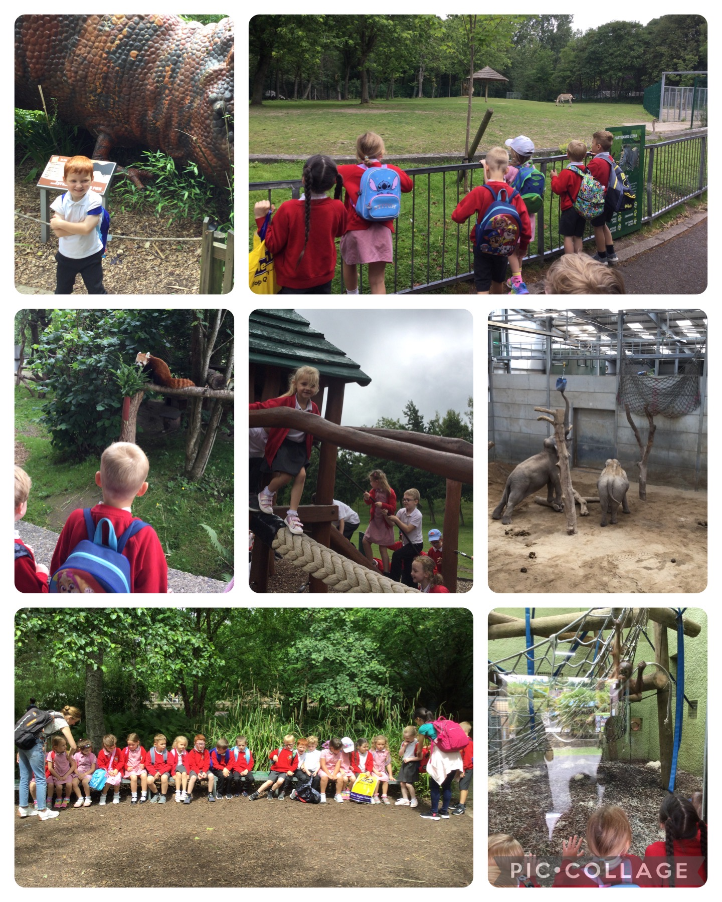

Some of our independent learning areas…..
